I. Frequency-domain inverse wave propagation problem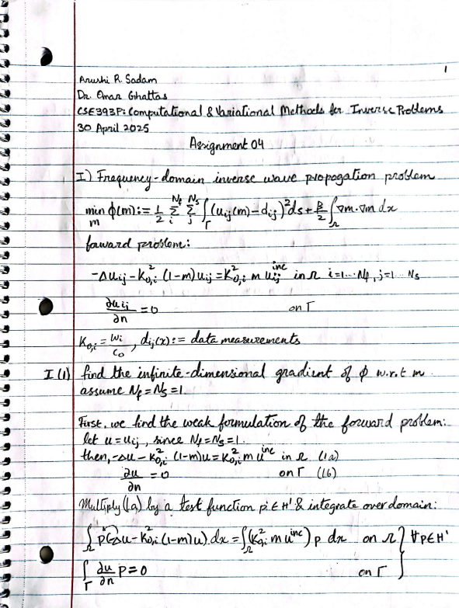 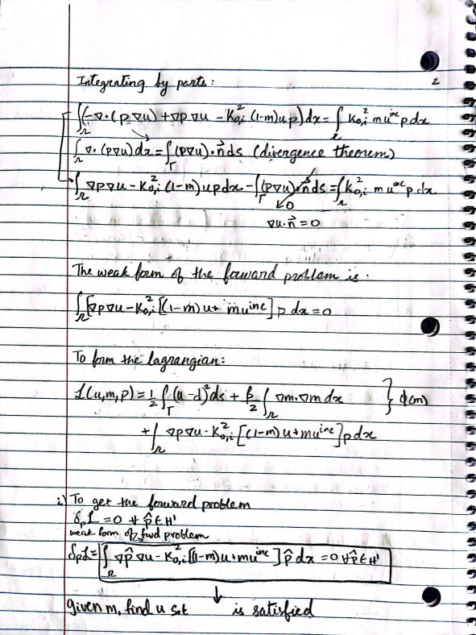 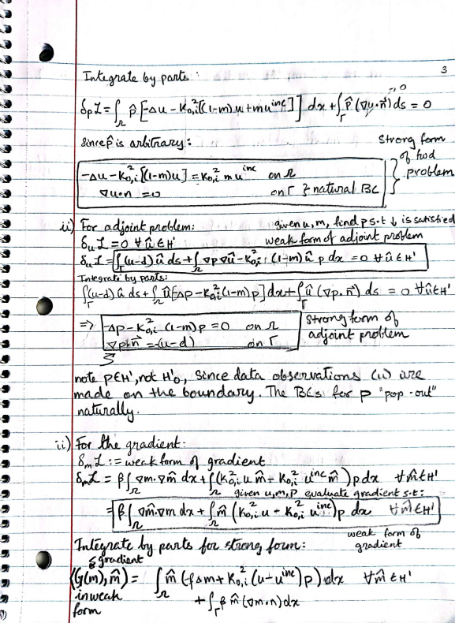 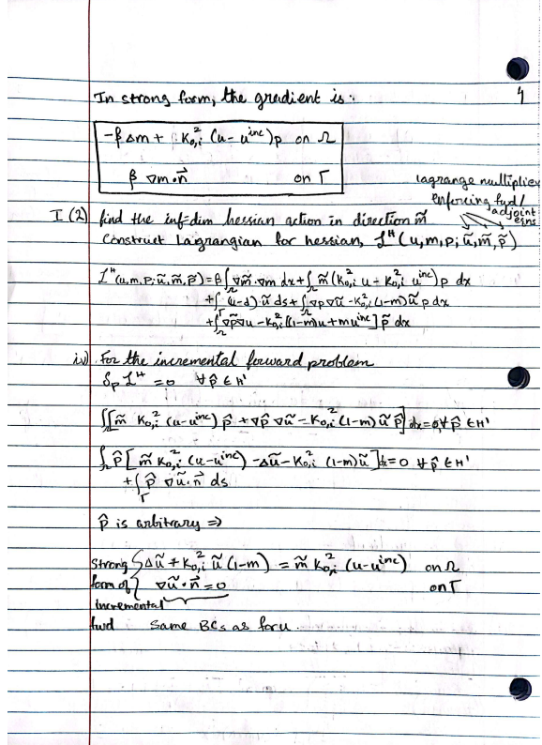 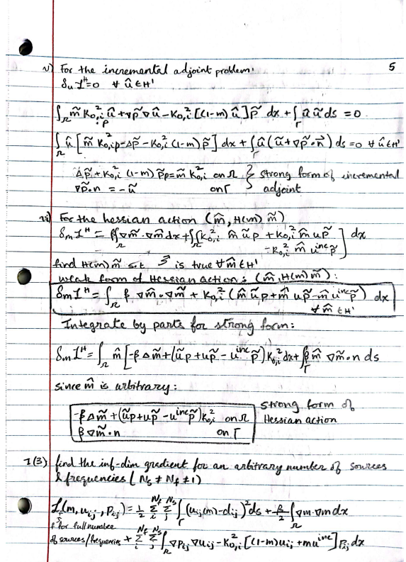 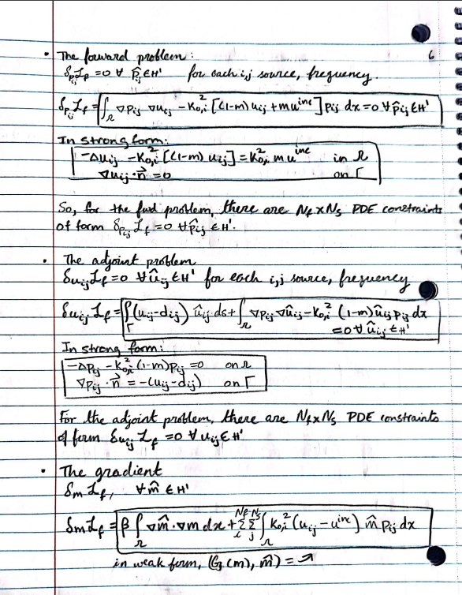 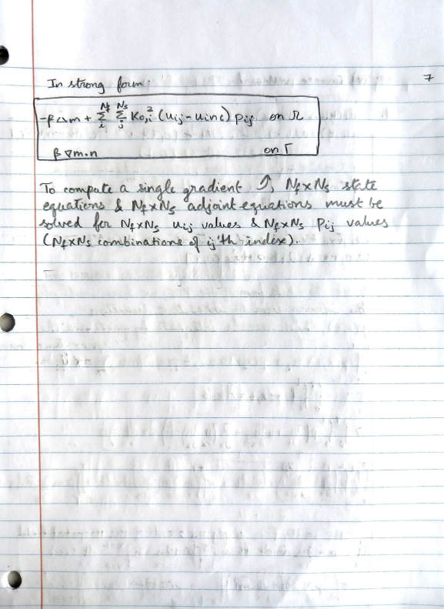

II. The steepest descent method for solving the Helmholtz inverse problem
Derivations:
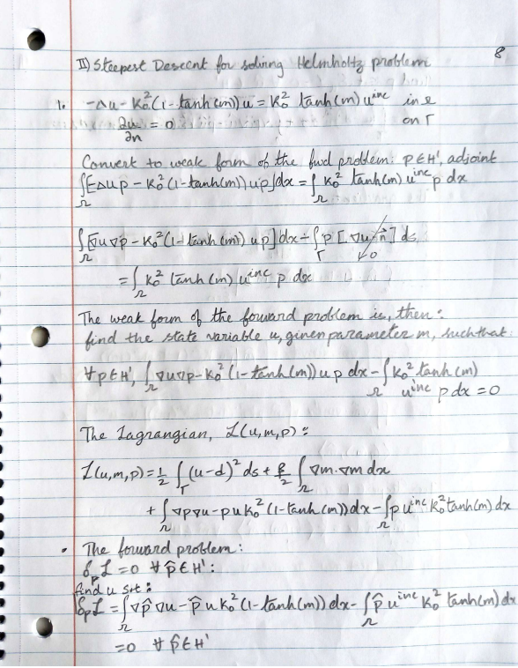
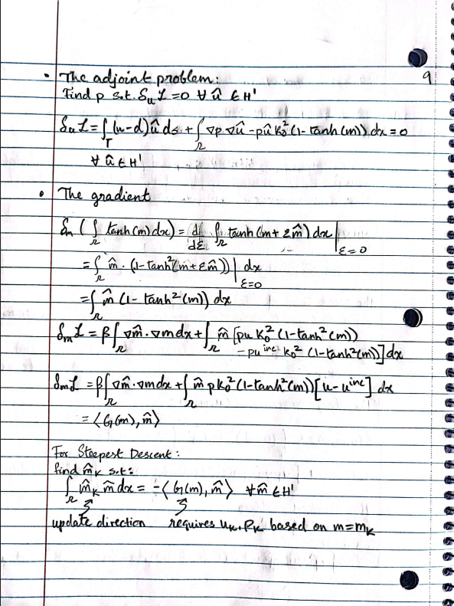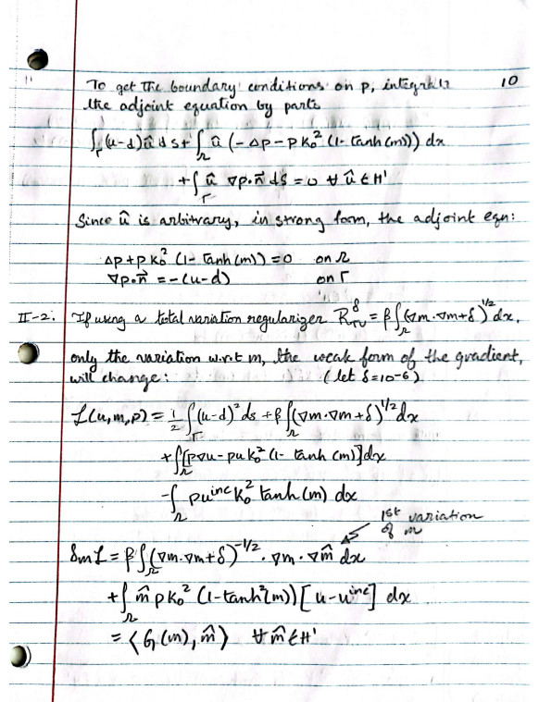
- Report the solution of the inverse problem and the number of required iterations (for a 1000 relative reduction in the norm of the gradient) for the following cases.
  - Yes, the problem converges with steepest descent (Tikhonov regularization, k0 = 5) in under 1,000 iterations. It takes 719 iterations for convergence to the below solution:
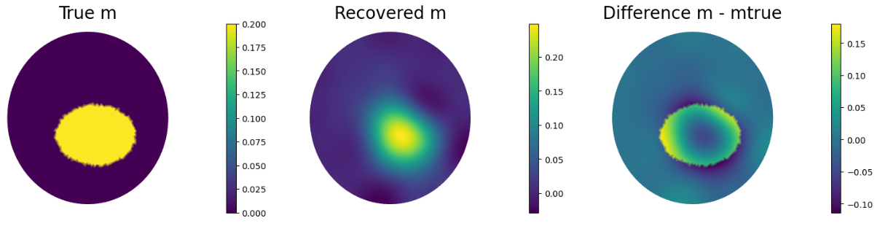
The L² error ${\left|\left|m-m_{true}\right|\right|}_{2}^{2}≈0.00472$.
Cost function: 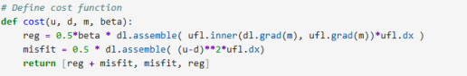
Gradient:
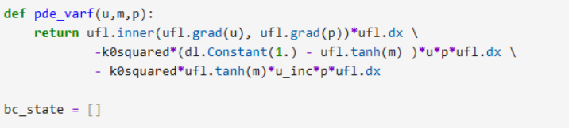
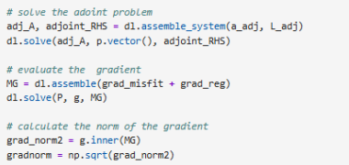
For further details on code, please refer to the Appendix.
  - With a H¹-inner product preconditioning, steepest descent (Tikhonov regularization, k0 = 5) converges to the below solution in 402 iterations, which is much faster than the L² -inner product preconditioning.
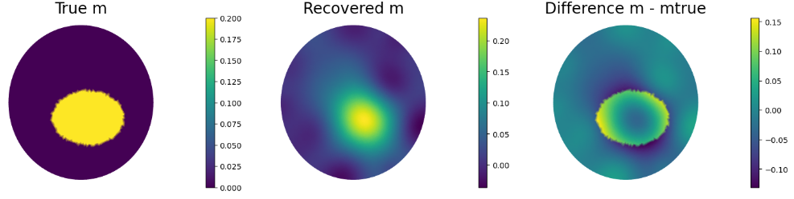
The L² error ${\left|\left|m-m_{true}\right|\right|}_{2}^{2}≈0.00565$, which is slightly higher (likely negligible) than the L² -inner product preconditioned solution.
  - With a higher wave number k0 = 10 (H¹-inner product preconditioning, Tikhonov regularization) steepest descent does not converge within 1000 iterations, and does not recover the parameter field (m) well. There is little-to-no recovery with 1000 iterations, so we assume that further iterations will not improve convergence. 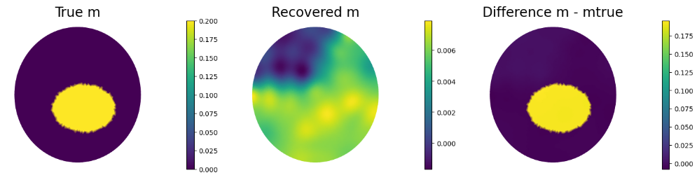
The L² error ${\left|\left|m-m_{true}\right|\right|}_{2}^{2}≈0.0202$, which is about 1 order of magnitude more error than for a lower wavenumber of k0 = 5.

- Steepest Descent for Helmholtz with Total Variation
The problem does not converge even after 2000 iterations when Total Variation regularization is implemented (steepest descent, k0 = 5, smoothening parameter .01 for TV regularization). The final result is:
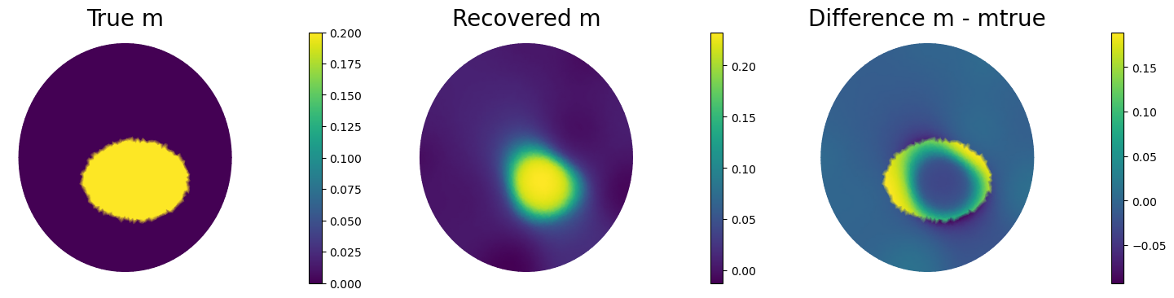
The L² error ${\left|\left|m-m_{true}\right|\right|}_{2}^{2}≈0.00576$, which is about the same as the Tikhonov regularized solutions for k0 = 5. However, notice that with TV regularization, a sharper parameter field is able to be reconstructed, compared to the blurred recovered parameter field with Tikhonov regularization. Further refinement could be achieved by varying the regularization parameter (currently set at 10⁻⁵) and the smoothing parameter for the regularization (set at .01). TV leads to a highly irregular/ill-posed loss function, so convergence constraints might need to be relaxed. Note that the gradient norm of TV regularized loss changes from about 10⁻² to 10⁻⁵, indicating substantial optimization and well recovery of the parameter field. (The gradient reduction tolerance is 10⁻³, which is almost achieved).
For k0 = 10, just as with Tikhonov regularization, the parameter field s not recovered well:
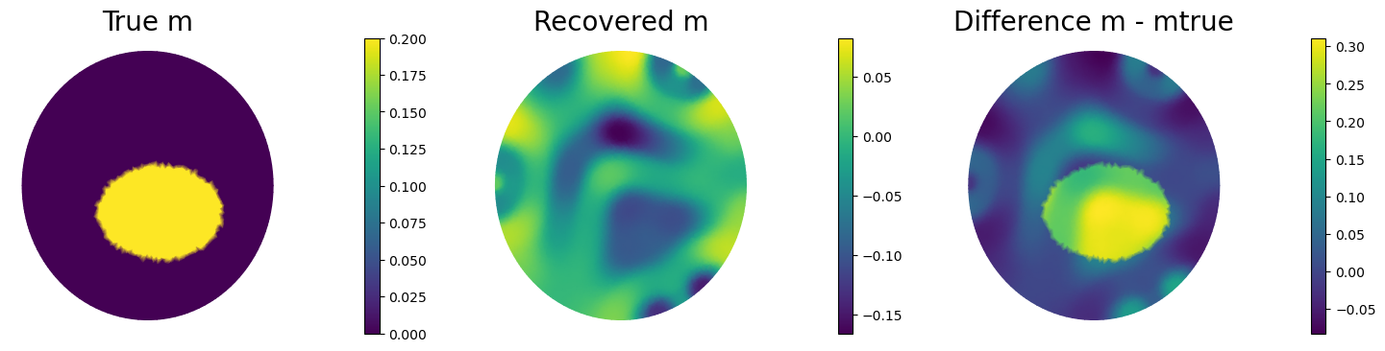The L² error ${\left|\left|m-m_{true}\right|\right|}_{2}^{2}≈0.0435$, which is about 1 order of magnitude more error than for a lower wavenumber of k0 = 5, and the solution does not converge in 2000 iterations.
Cost function:
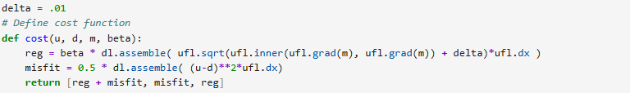
Gradient:
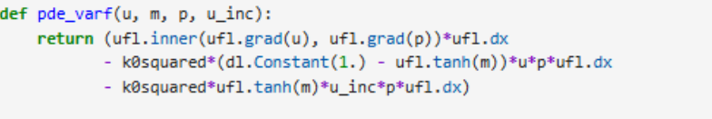
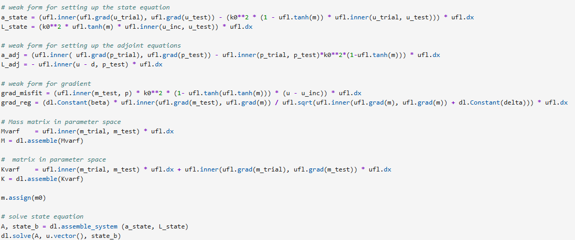
- With multiple sources superposed independently, k0 = 5, Tikhonov regularization, and steepest descent, we achieve the below solution:
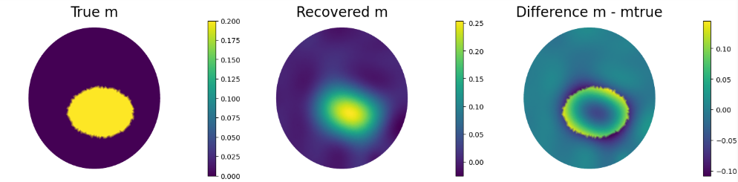

The L² error ${\left|\left|m-m_{true}\right|\right|}_{2}^{2}≈0.00353$, which is marginally better than the error when the sources are superimposed (II.1.a, error of 0.$00472$). The results seem to have more resolution/crispness (more similar to the Total Variation regularization in II.2 than Tikhonov), than when the sources are superimposed.
If a k0 = 10 is used, steepest descent does not converge in 1000 iterations, and the parameter field recovery is still quite poor:
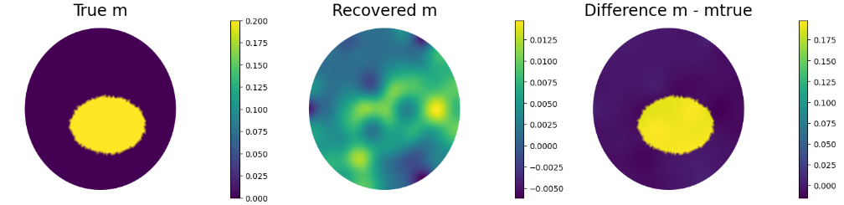
The L² error ${\left|\left|m-m_{true}\right|\right|}_{2}^{2}≈0.0203$, which is slightly better than the error when the superimposed (II.1.c, error of $0.0435$), but still extremely bad in terms of parameter recovery accuracy. Overall, the results seem slightly better than when the sources are superimposed, but they generally take some more computational expense.

III. The inexact Newton-CG method for solving the Helmholtz inverse problem
Derivations:
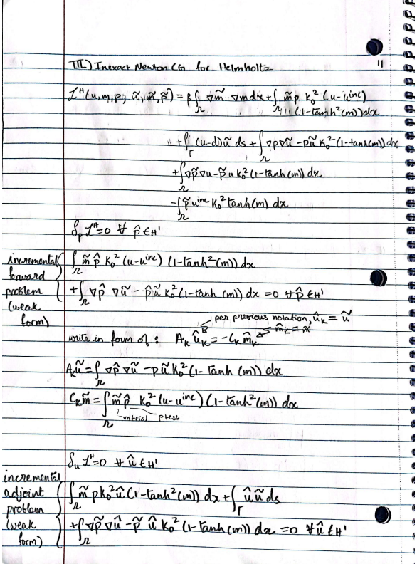
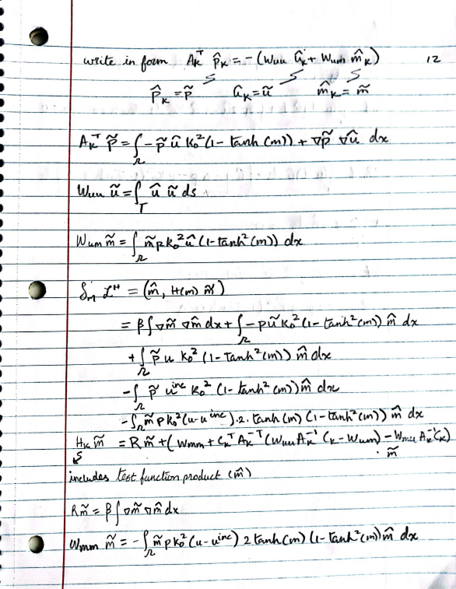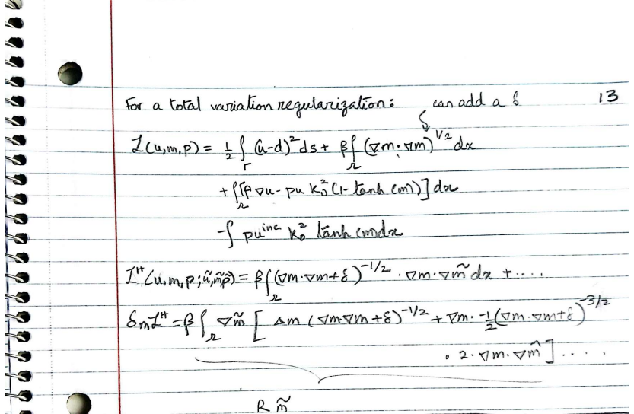
- Solve the inverse problem for 3 levels of mesh refinement and report the number of Gauss Newton and CG iterations for each case.
First, the optimal regularization is determined (2nd code block in Appendix). The optimal regularization is chosen manually (between 1e-8 and 1e-2) by finding the regularization that best reconstructs the “true” medium properties.
For mesh 1 (coarsest mesh), we notice a regularization of 1e-6 seems ideal, visually:
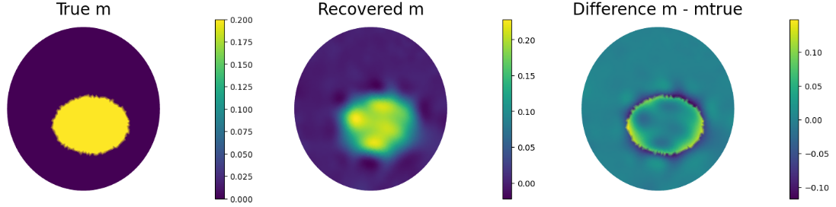
For a regularization of 1e-7, we achieve the minimal L2 difference between the true and recovered parameter fields: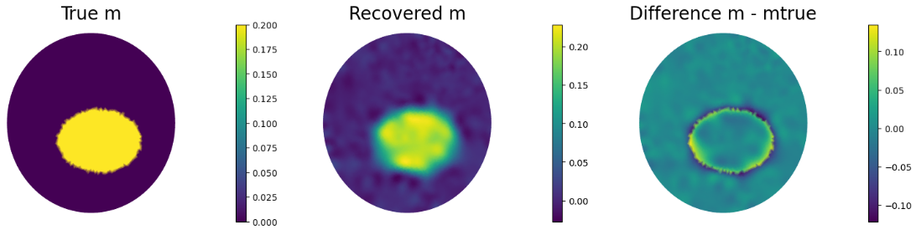
For refinement 0, a regularization of 1e-7 seems the best (numerically) while visually, 1e-6 seems better (smoother parameter field). 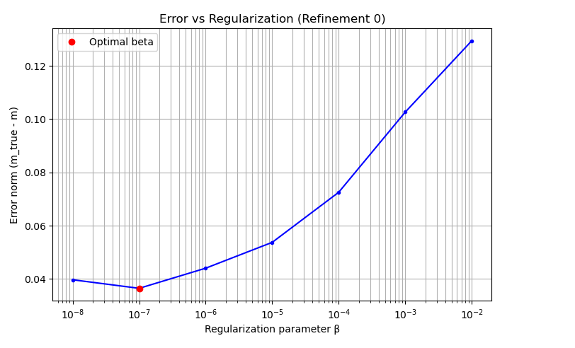
For refinement number 1:
Numerically, the least error is found for a regularization of 1e-8:
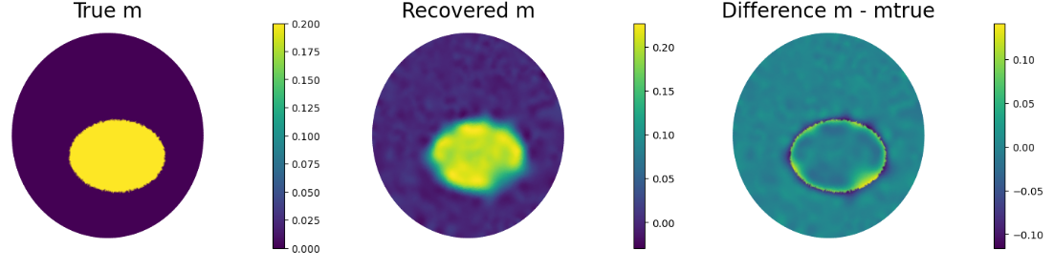
Regularization of 1e-7 seems ideal, visually:
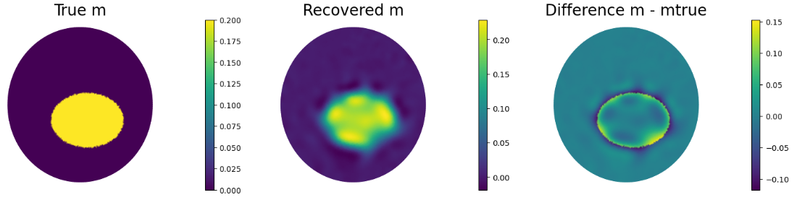
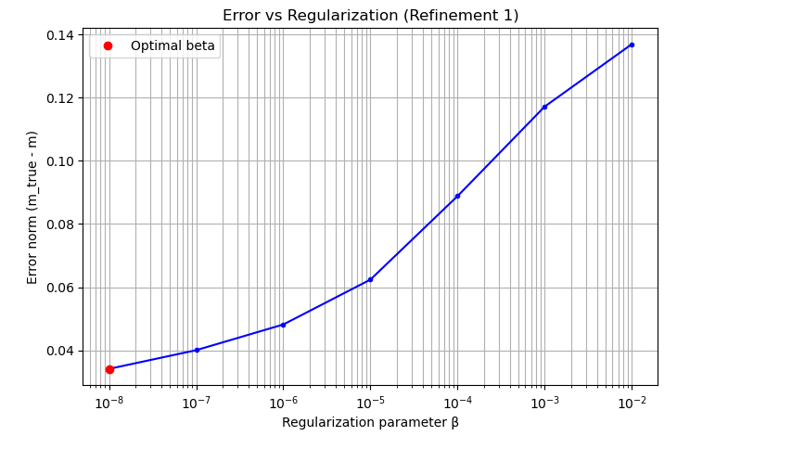
For refinement 2:
Numerically, the least error is found for a regularization of 1e-8: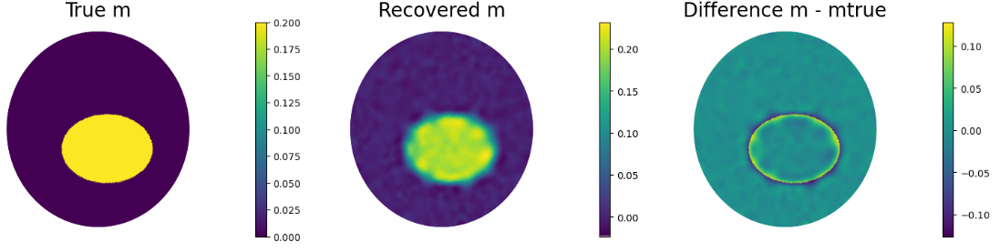
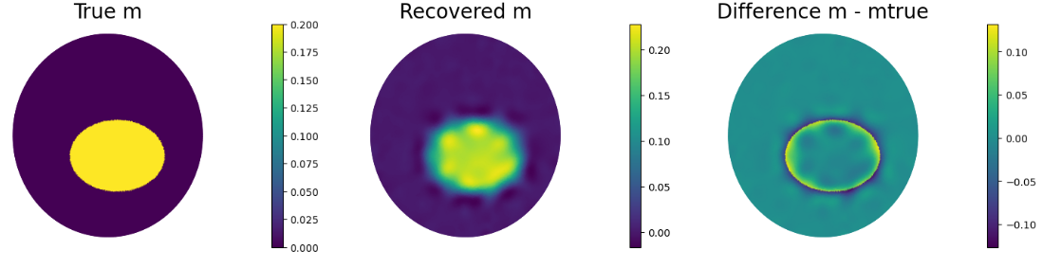
Visually, 1e-6 seems best:

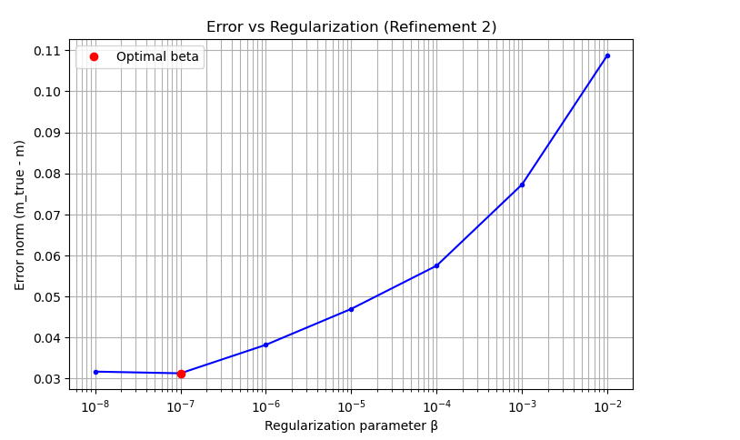
Based on the numerically chosen regularization parameter (1e-7 for the coarse mesh, 1e-8 for refinement 1 and 1e-7 for refinement 2), we have the following iteration results 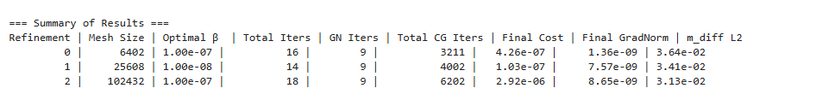
Increasing the mesh refinment seems to increase the number of CG iterations, while the number of toal Newton iterations remains roughly constant. The nonlinearity of the problem, thus, does not change as the mesh is refined. The increase in CG iterations is expected: refining the mesh increases the number of degrees of freedom, which leads to larger and potentially more ill-conditioned linear systems to solve at each Newton step. Consequently, more CG iterations are required to solve the linearized subproblems to the desired tolerance.
For a comparision at the same regularization level, we choose a regularization of 1e-6:
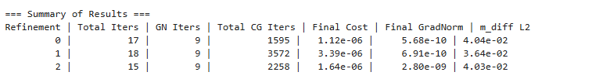
Again, the number of Newton iterations for convergence remains roughly constant; this is as expected since Newton convergence is independent of parameter/problem dimension. Meanwhile, CG iteration counts still exhibit a slight increase with refinement, reflecting the increasing size and complexity of the discretised forward/adjoint operators.
Cost function, gradient are same as in the steepest decent code for problem II.
Hessian action:
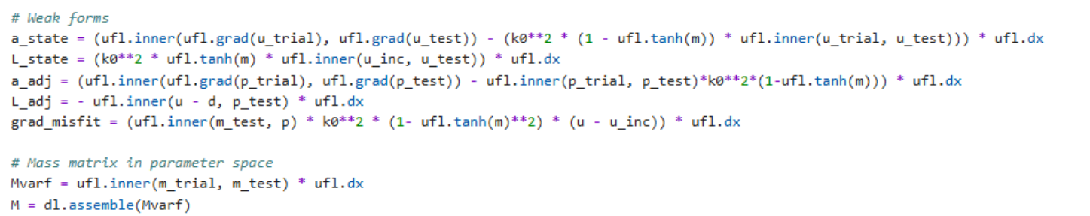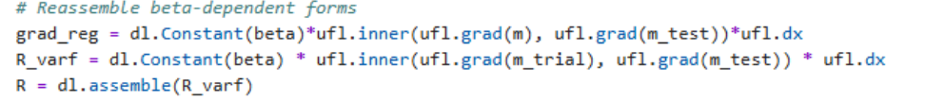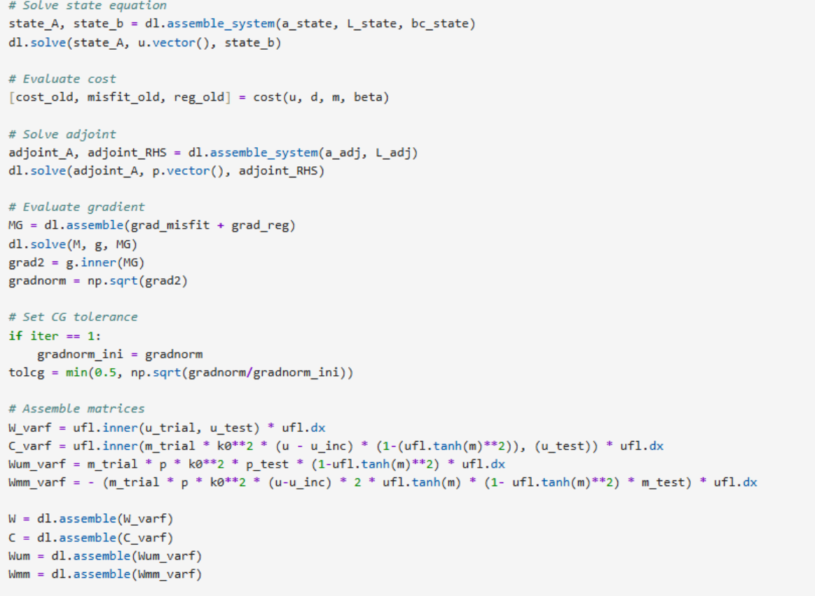
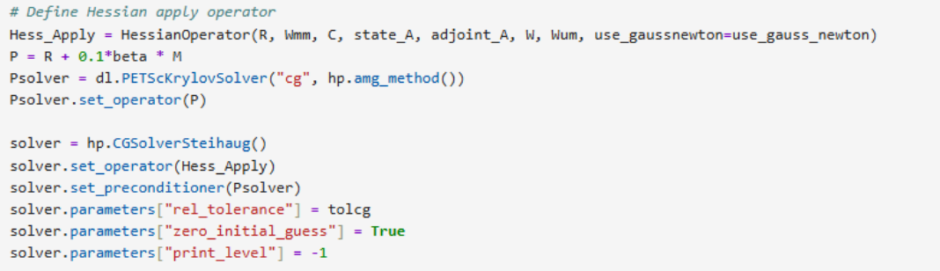
- Spectrum of regularization-preconditioned Hessian at solution of inverse problem
  - As the mesh is refined, the eigenvalues generally become more spread apart:
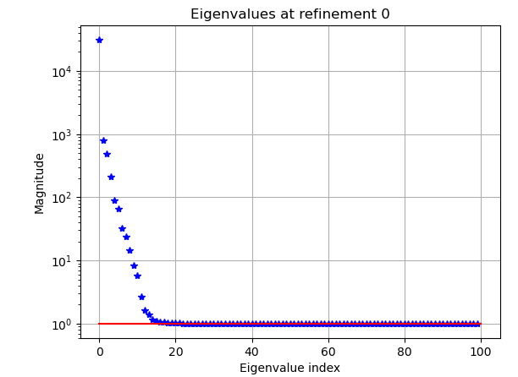 | Max eigenvalue: 31,148  Min eigenvalue: ~1  Condition number : 3.11e+04
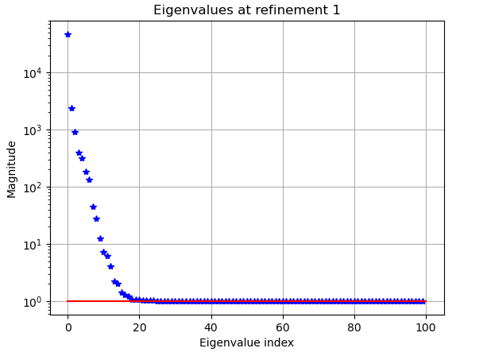 | Max eigenvalue: 46,862  Min eigenvalue: ~1  Condition number : 4.69e+04
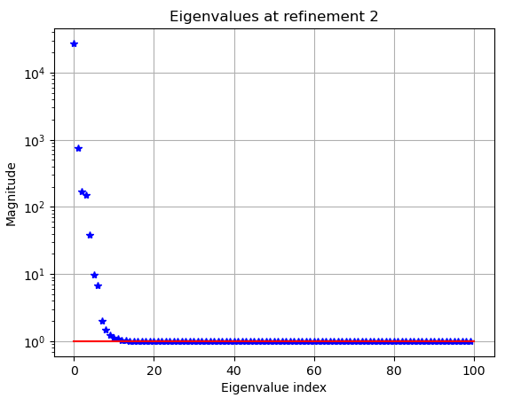 | Max eigenvalue: 27,208  Min eigenvalue: ~1  Condition number: 2.72e+04
As refinement increases, the eigenvalue range of the Hessian seems to increase. The condition number also seems to generally increase as the mesh is refined, suggesting that the problem becomes less well-posed as refinement increases. With more degrees of freedom/higher dimension, the Hessian can capture more intricacies that are inherent to small scale problems, decreasing the stability of the problem while allowing for more details of the parameter field to be recovered. Notice that only the maximum eigenvalues are increased; the small eigenvalues of magnitude ~1 remain constant (these are preconditioned/affected by the regularization).
For comparison, the non-regularized precondition hessian eigenvalues are:
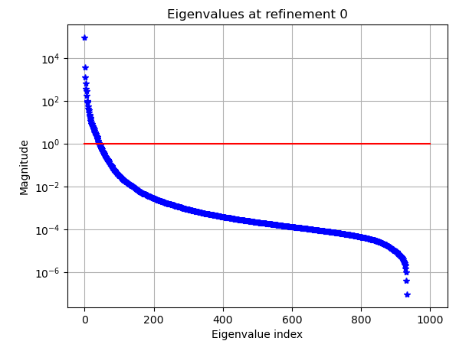 | Max eigenvalue: 96,494  Min eigenvalue: -9.01e-5  Condition number : -1.07e+09
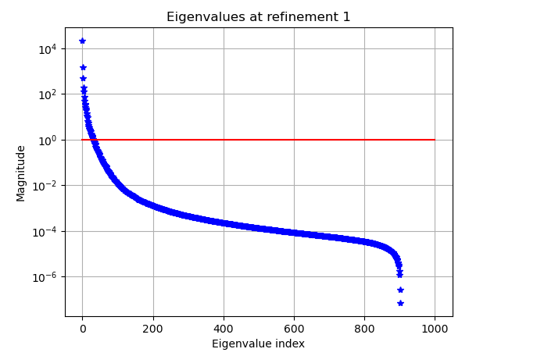 | Max eigenvalue: 22,061  Min eigenvalue: -3.39e-4  Condition number : -6.51e+07
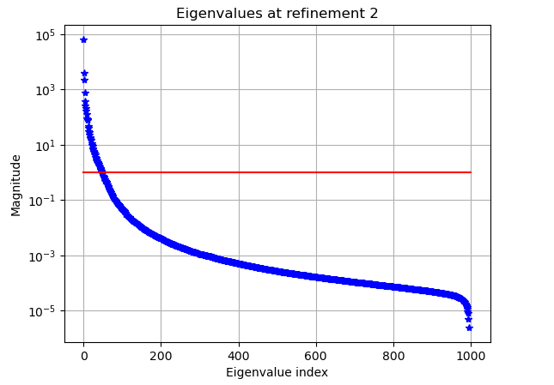 | Max eigenvalue: 63,674  Min eigenvalue: -2.41e-06  Condition number: 5.09e+09

  - For k0​=5.0, the max eigenvalue is ~34,332. For k0​=10.0, the max eigenvalue is ~3,488. For k0​=12.5, the max eigenvalue is ~ 113,784. The minimum eigenvalues for all of these are 1.
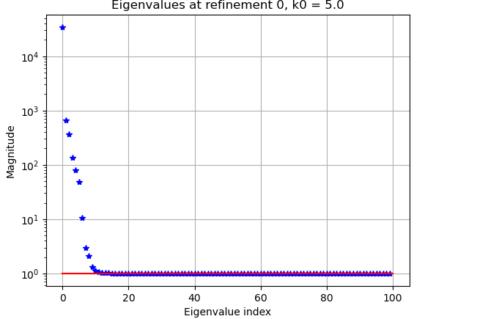
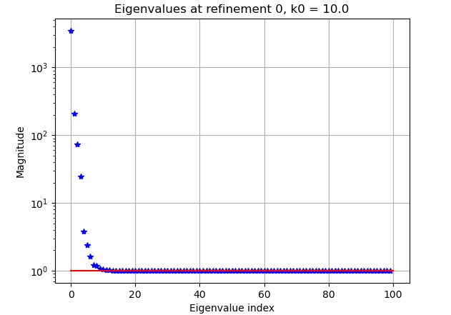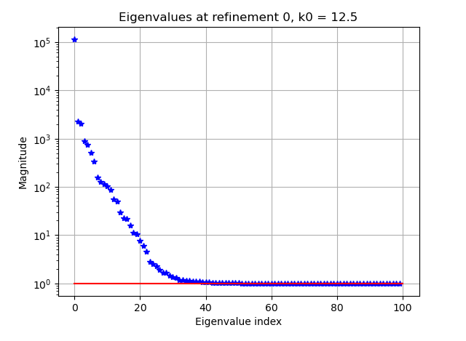

The Hessian matrix is derived from the data misfit and the regularization. The misfit term is influenced by the Helmholtz equation’s sensitivity to the parameter m, which is dependent on k0. Larger k0 (higher frequency) leads to higher sensitivity of the solution u to the parameter m, which amplifies the eigenvalues of the misfit part of the Hessian. So, as k0 increases, the largest eigenvalues (corresponding to the misfit of the Hessian) also grow. Meanwhile, the regularization affects/boosts the smaller eigenvalues. Since we are plotting the regularized-preconditioned Hessian’s eigenvalues, the smaller eigenvalues are boosted to be at a minimum of 1, instead of decaying to 0. The condition number seems to increase as the wave number increases, suggesting worse conditioning of the inverse problem.
Utilizing frequency hopping to solve the high-frequency Helmholtz problem allows for the number of Newton and CG iterations to remain low (between 100 – 400 CG iterations for about 12 Newton iterations) as the frequency is increased. As the frequency is increased, we observe more instability and slower CG convergence (~400 CG iterations compared to the ~100 CG iterations for the coarse mesh).

- With Total Variation regularization, we weaken the constraints for convergence: instead of a 1e-8 factor reduction in gradient norm, we seek a minimum of 1e-4 factor reduction in the norm of the gradient (leading to a gradient norm of about 1e-5). Total variation has a highly non-linear landscape, so even a 1e-4 relative error is quite good in terms of parameter recovery.
For refinement 0 (coarsest mesh):
At a regularization of 1e-6:
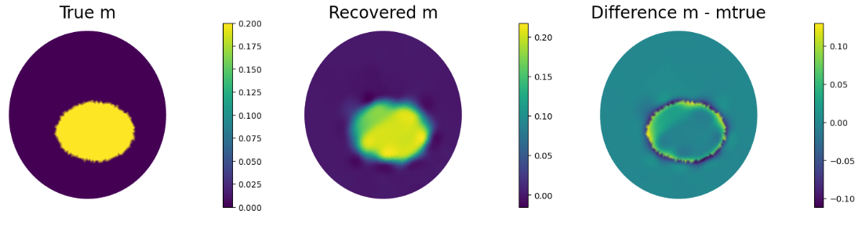
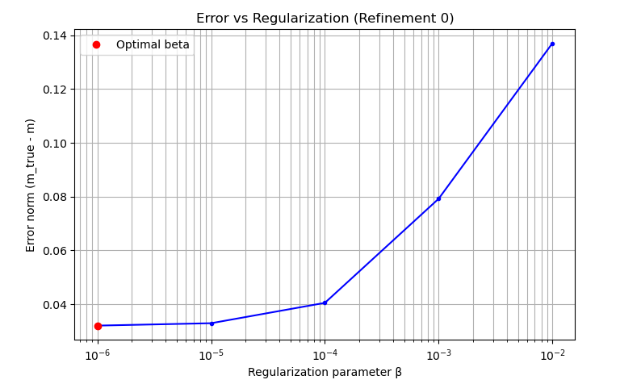
For refinement 1:
At a regularization of 1e-6:
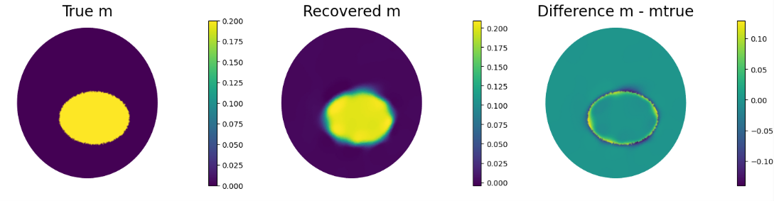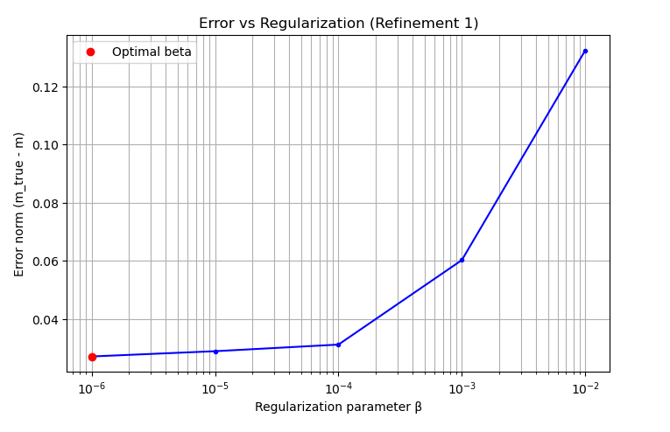
For refinement 2:
At a regularization of 1e-6: 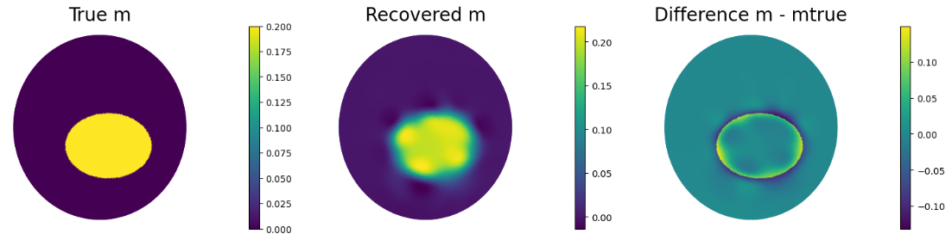
At a regularization of 1e-5:

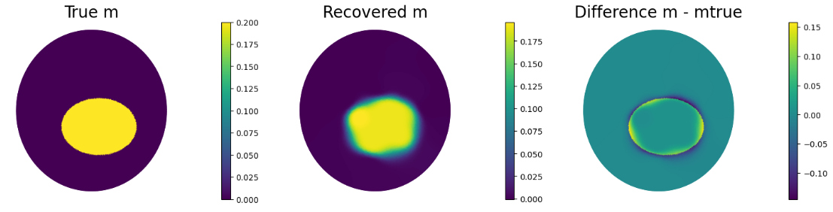
Visually and numerically, a regularization of 1e-5 seems better at reconstructing the parameter field. Note that due to high runtimes, further values of regularization were not tested.
At the same regularization of 1e-6, we observe:
Mesh Refinement | Newton Iterations | CG Iterations
0 | 12 | 978
1 | 14 | 2651
2 | 14 | 365
At the ideal regularizations (different regularization for optimal parameter recovery at each refinement):
Mesh Refinement | Regularization (minimal error in parameter recovery) | Newton Iterations | CG Iterations
0 | 1e-6 | 12 | 978
1 | 1e-6 | 14 | 2651
2 | 1e-5 | 19 | 1139
Total variation generally takes more CG iterations for convergence as the mesh is refined. This is similar to problem 1 (Tikhonov regularization), where the higher problem dimension requires more linear iterations for convergence at each Newton step. Additionally, the number of Newton iterations for convergence remains mostly stable across mesh refinement.
Total variation regularization requires a few more CG iterations for convergence than for Tikhonov regularization. In problem 1 (Tikhonov regularization) and problem 3 (total variation), both methods take between 1000-2000 iterations to converge. However, total variation has a much higher gradient tolerance for converge (1e-4 vs. 1e-8 for the Tikhonov regularization problem); so, we can conclude that total variation leads to more numerically unstable problems that require large numbers of CG iterations for convergence (more so than for problems using Tikhonov regularization). Notice that one order of magnitude change in regularization (from 1e-6 to 1e-5) increases the number of CG iterations by about a factor of 4; this suggests that total variation convergence is highly dependent on regularization tuning (at least more so than for Tikhonov regularization) to supress fine instabilities/noise while still maintaining crisp/sharp edges in the parameter field.
Cost function/gradient/hessian action:
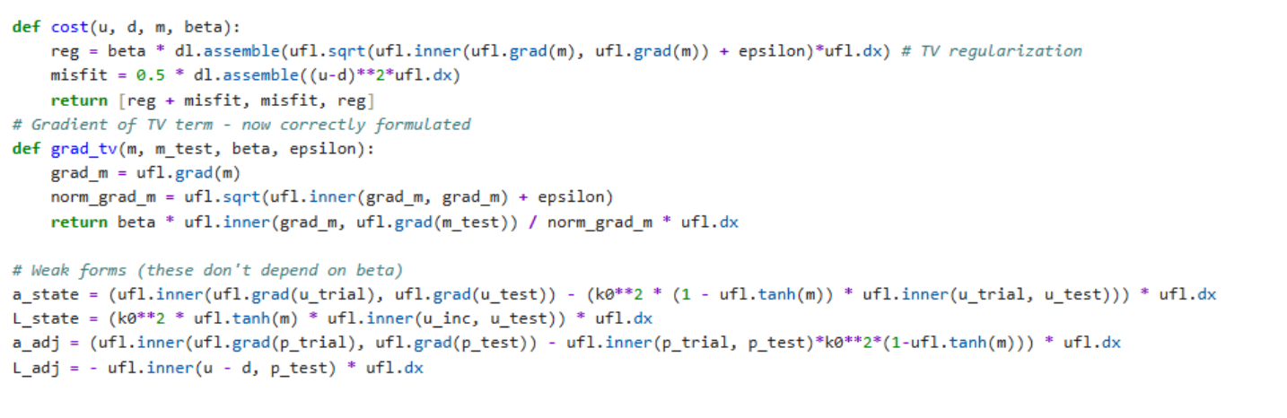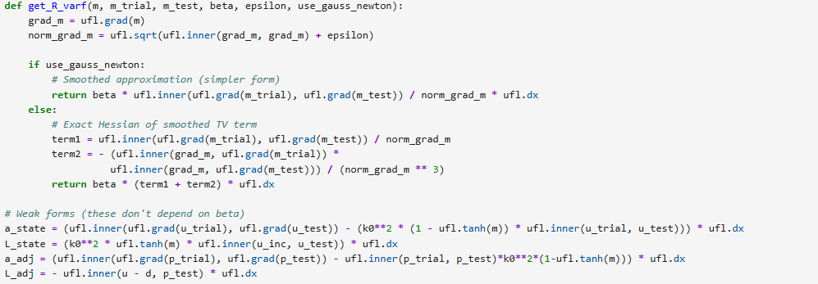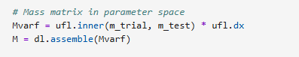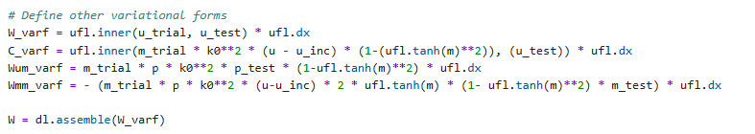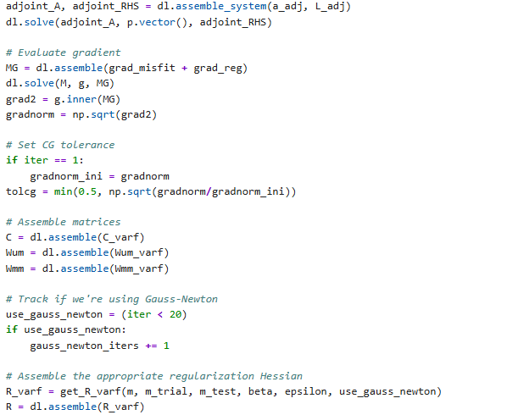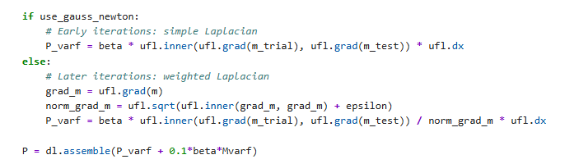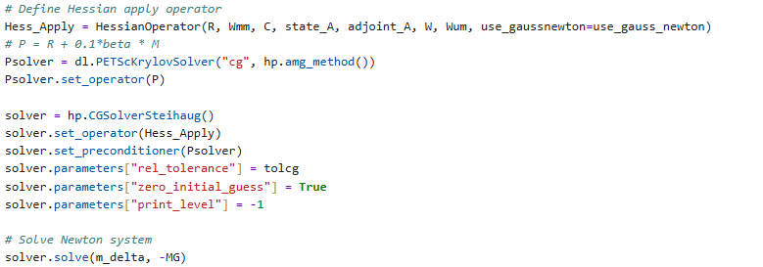

IV. Inverse Problem for Burger’s Equation 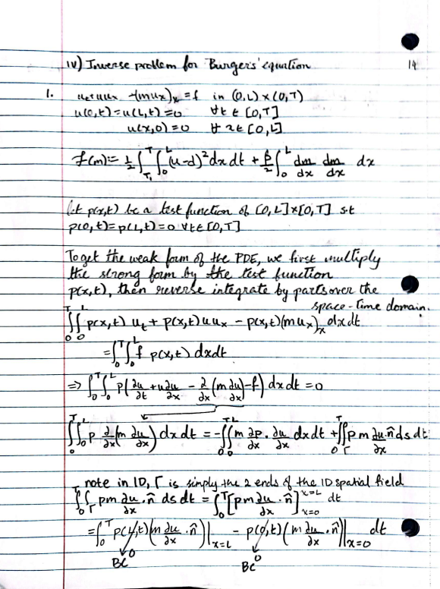 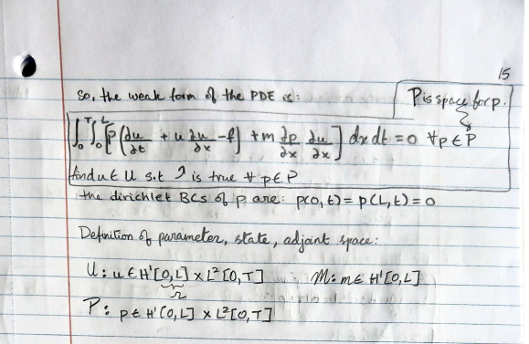 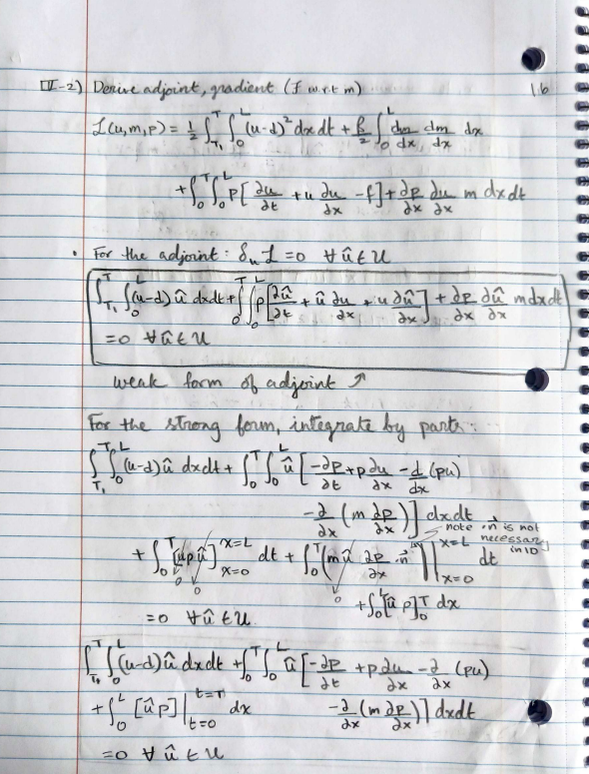
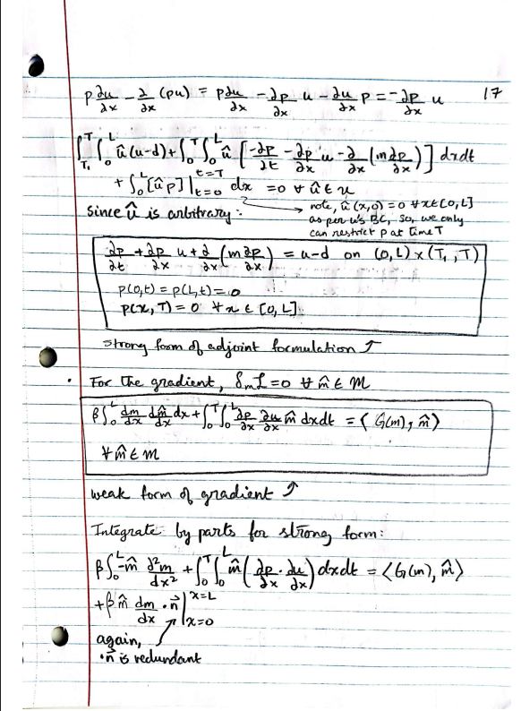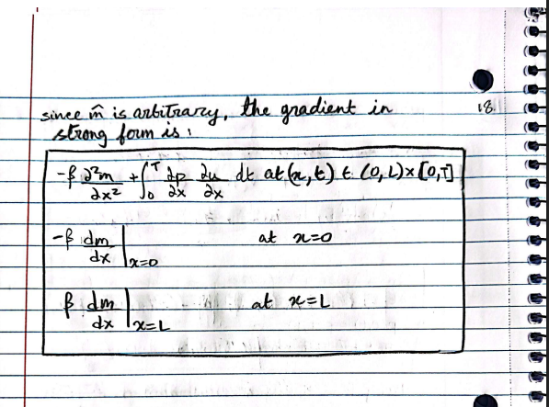

Appendix (codes for above problems):
II.1.a
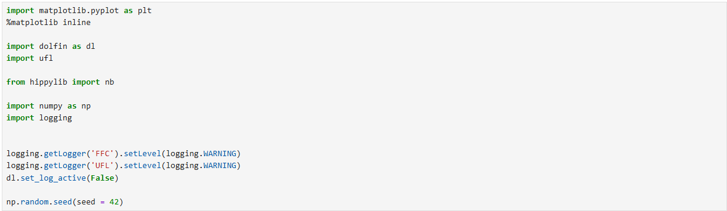
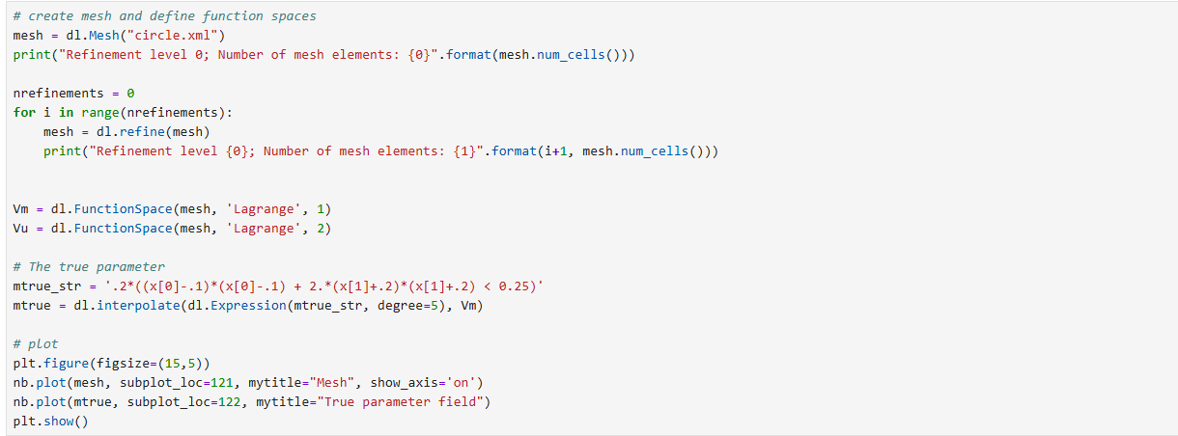
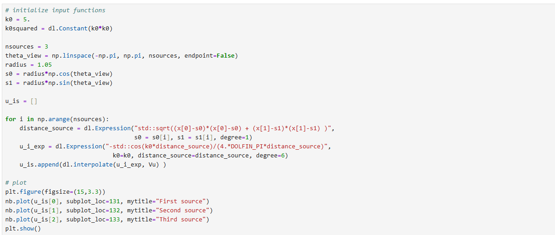
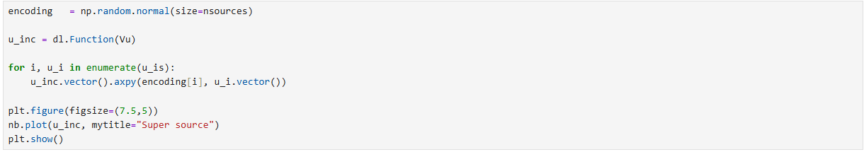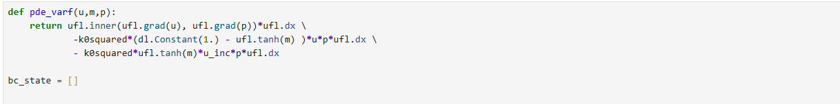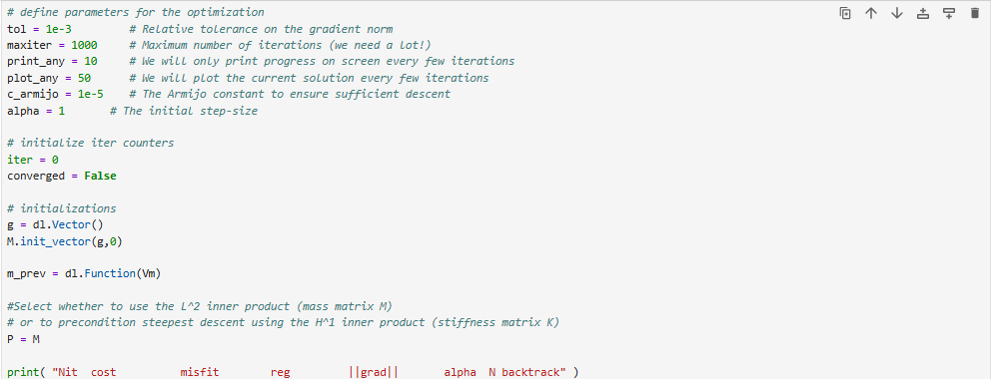
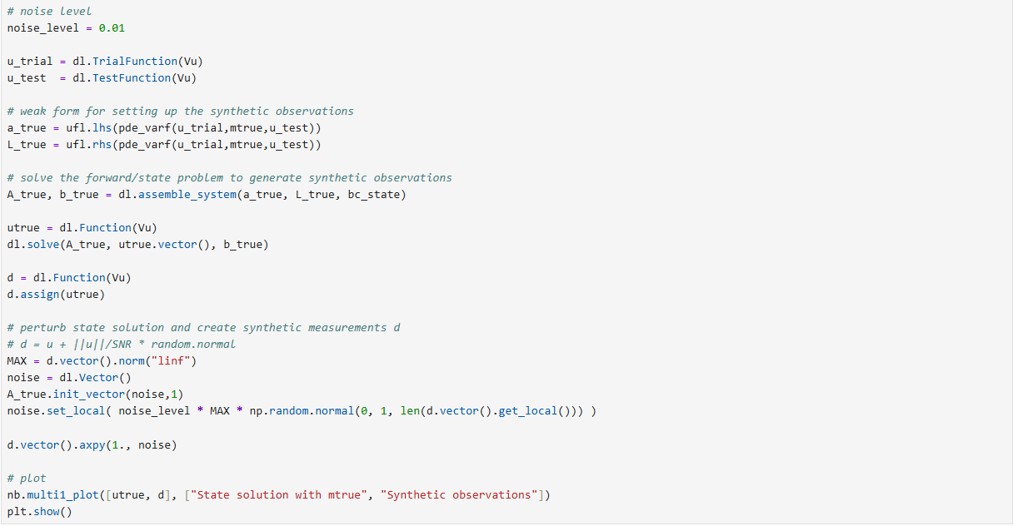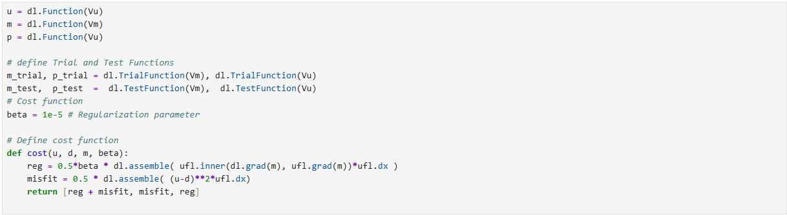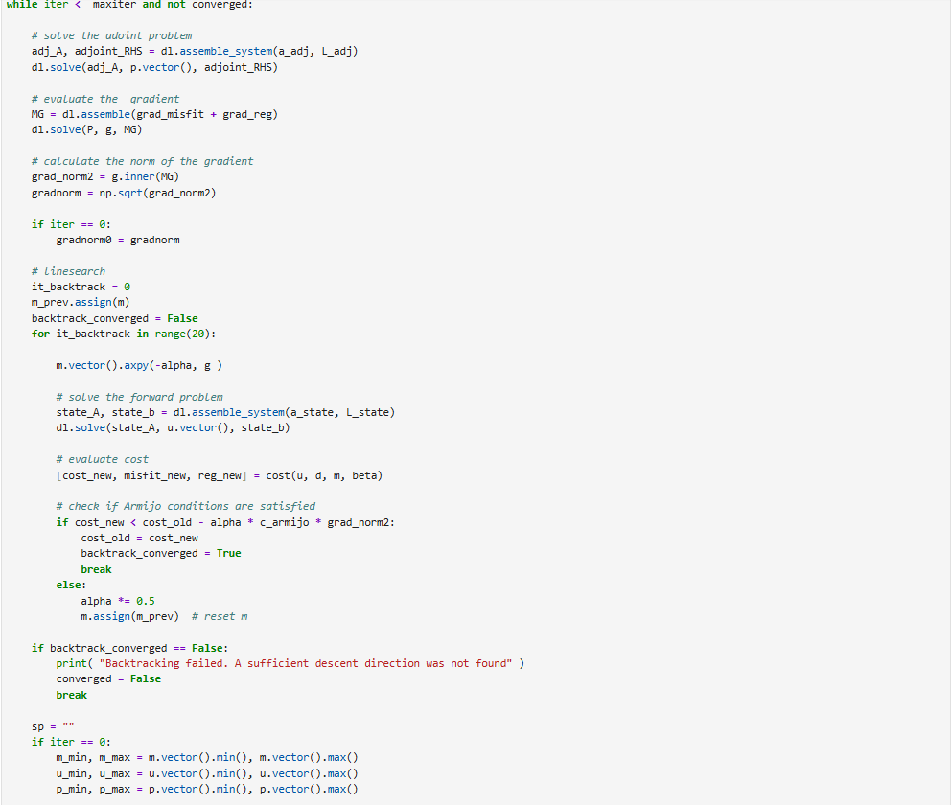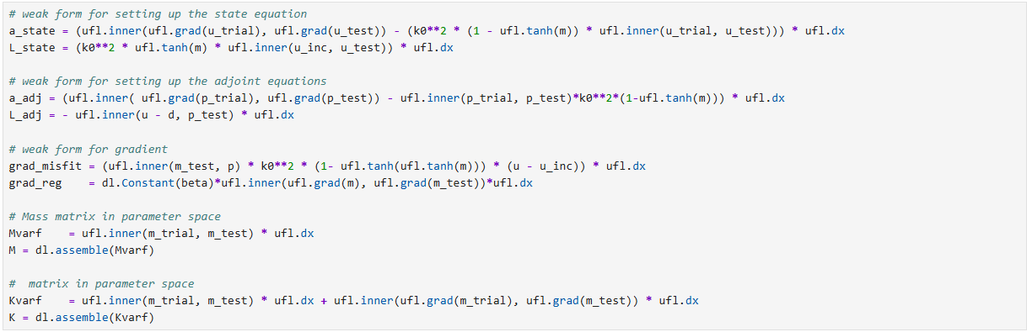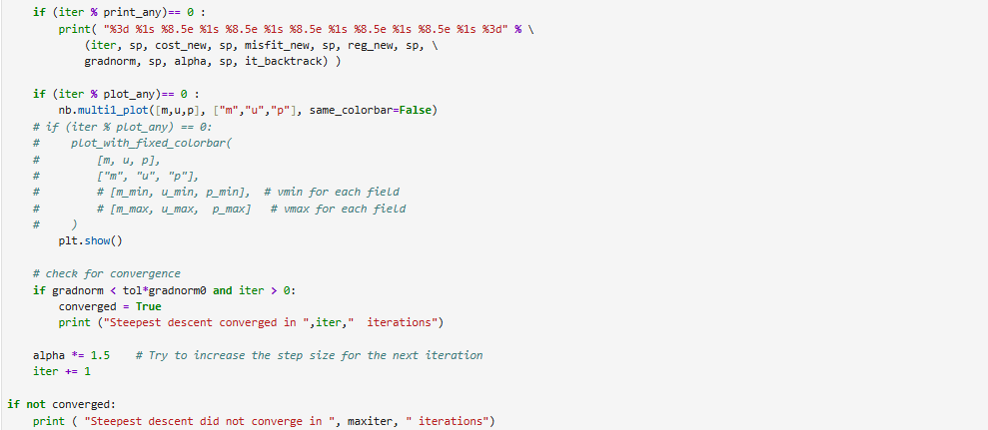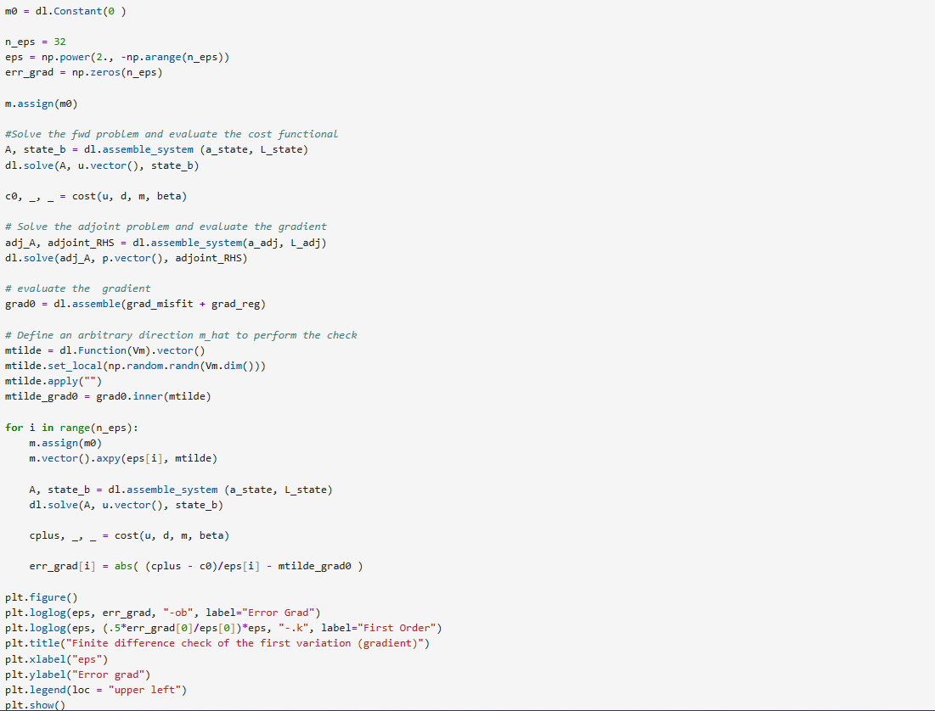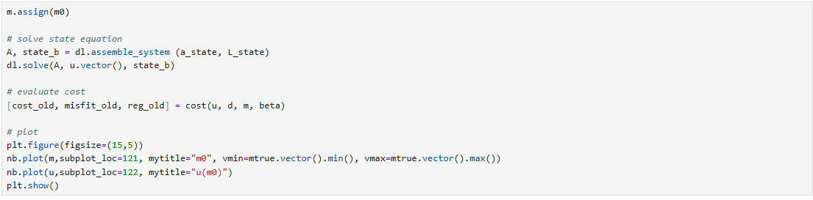
II.1.b
Same code as in II.1.a, until the setup for descent/optimization loop. The only change is P = K, rather than P = M: 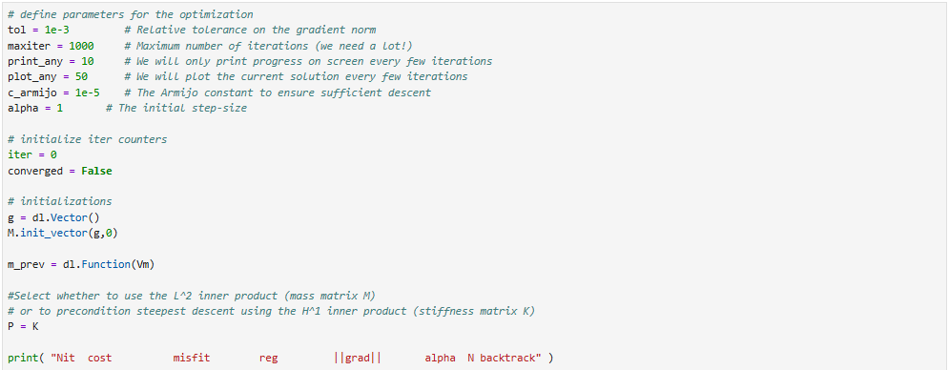
II.1.c
Exact same code as in II.1.a, except that k0=10 (assigned during source setup, after mesh setup):
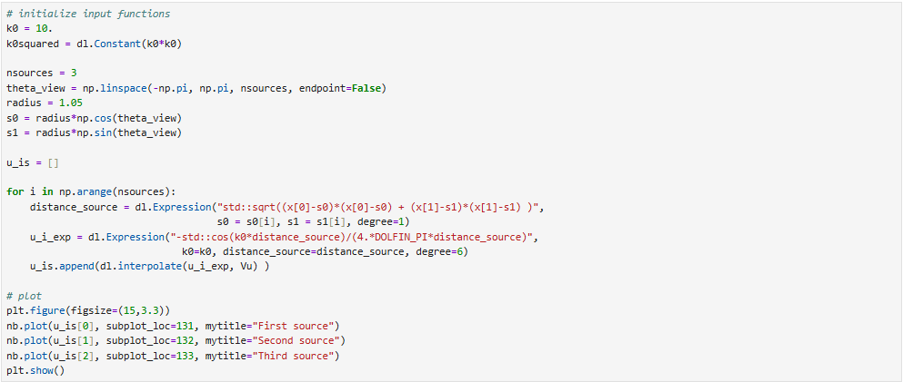

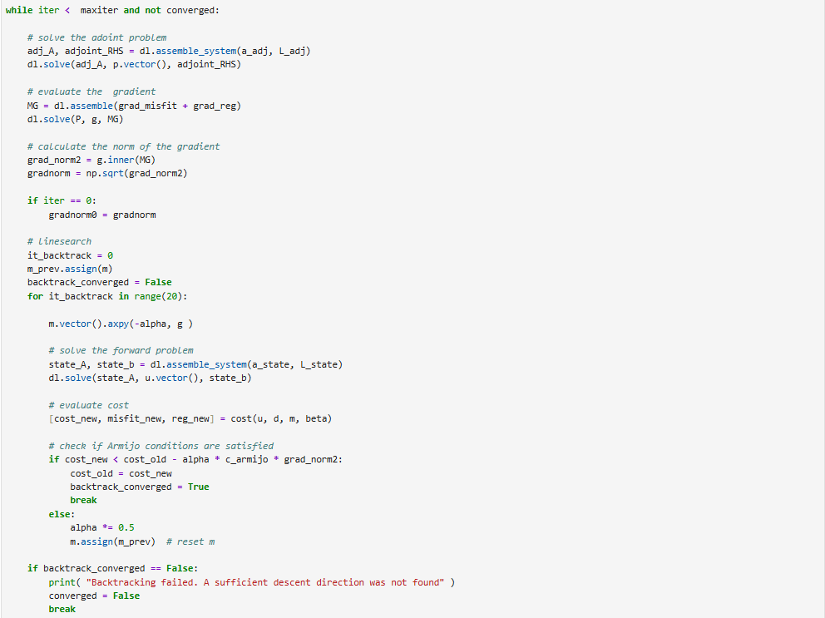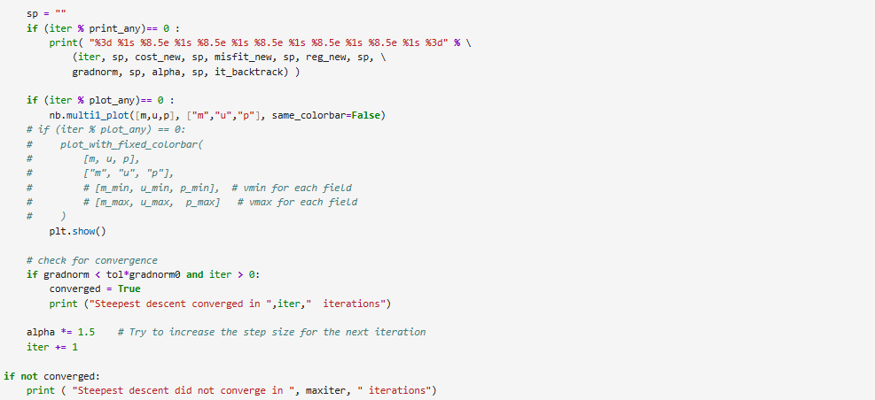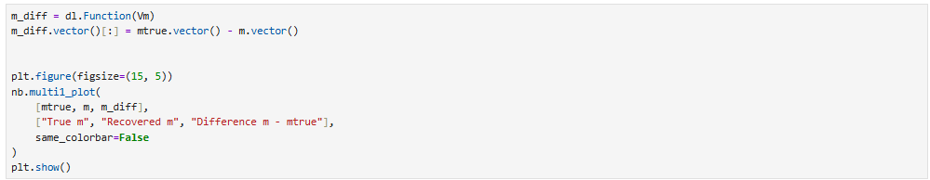
II.2
Same mesh setup as in II.1.a, then, k0 is reset to 5 and regularization is changed to Total Variation.
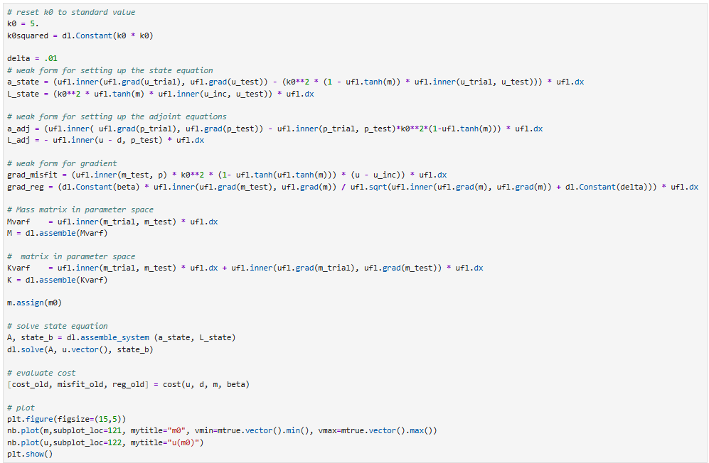
Same descent loop as in II.1.a, except max iterations increased to 2000:
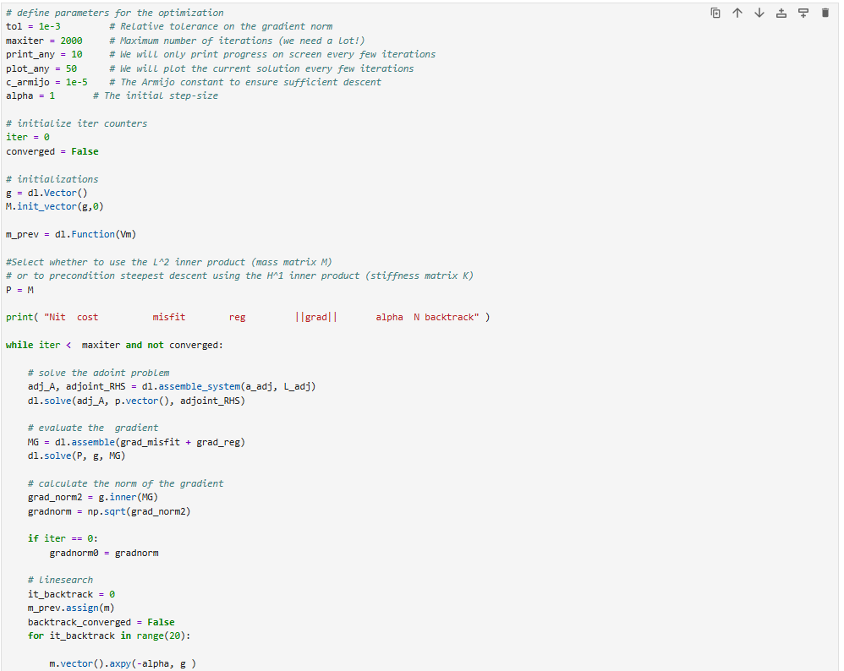
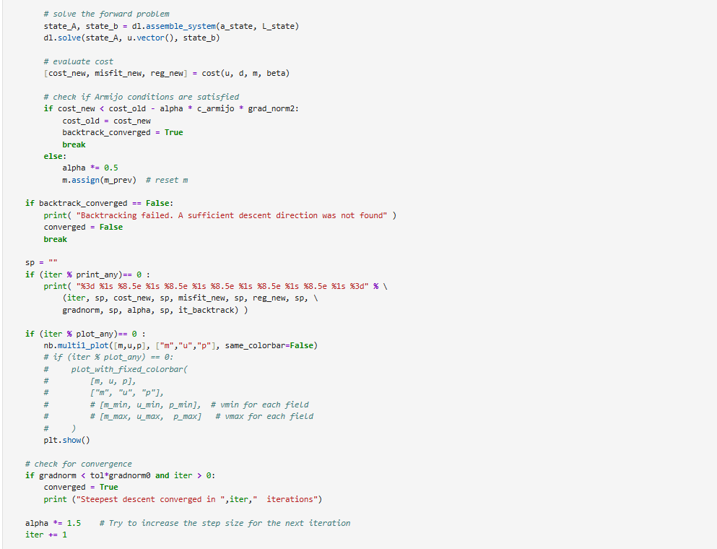
k0 is changed to 10, and the process is re-run.
II.3
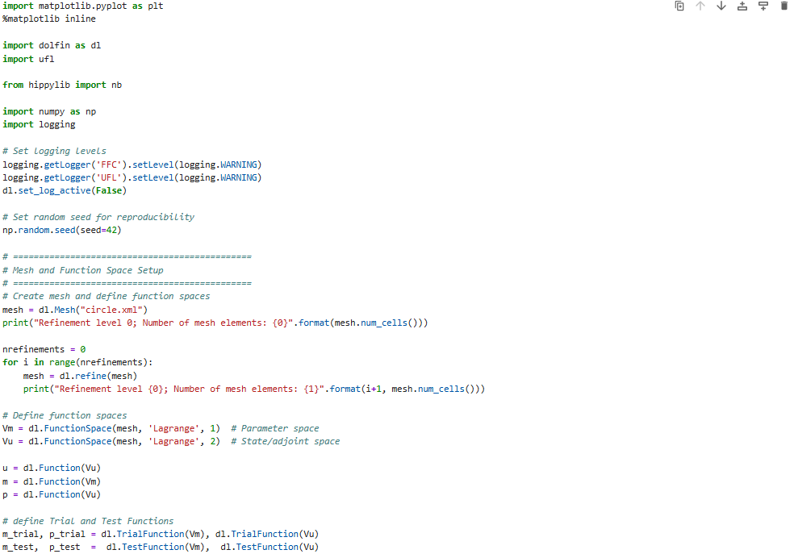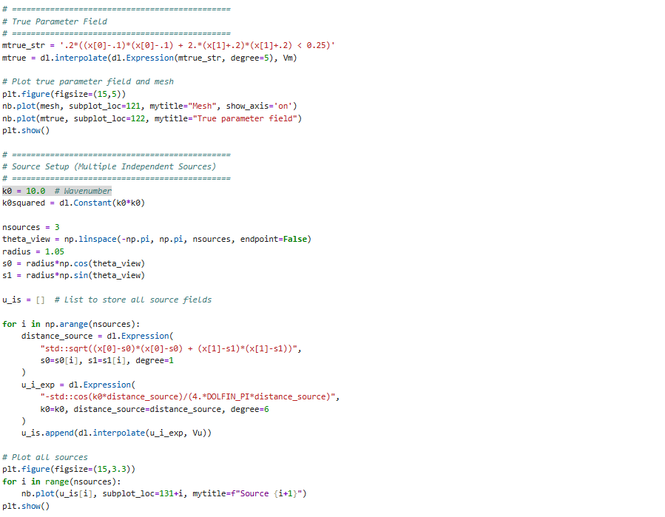
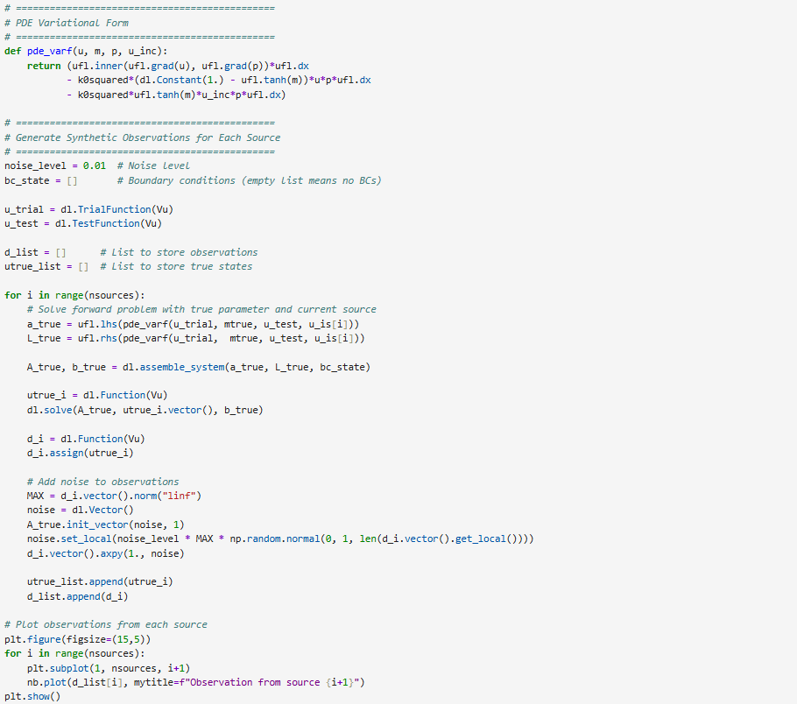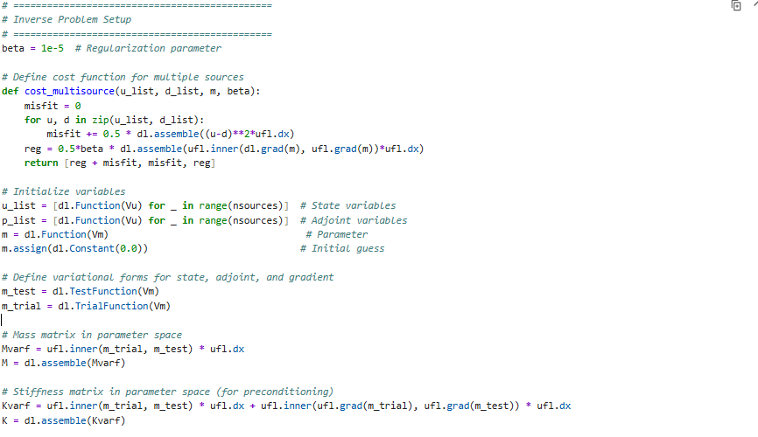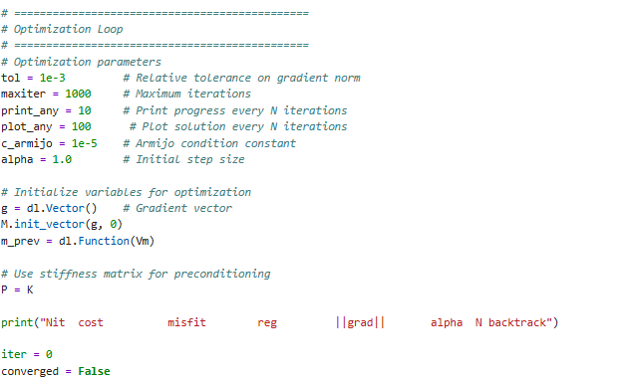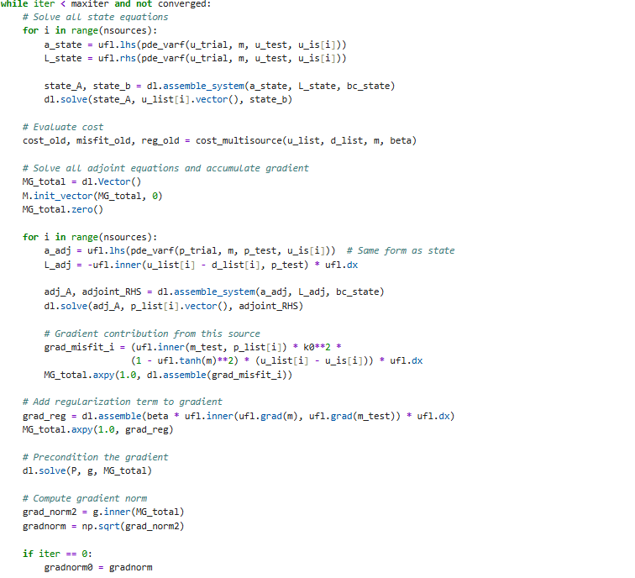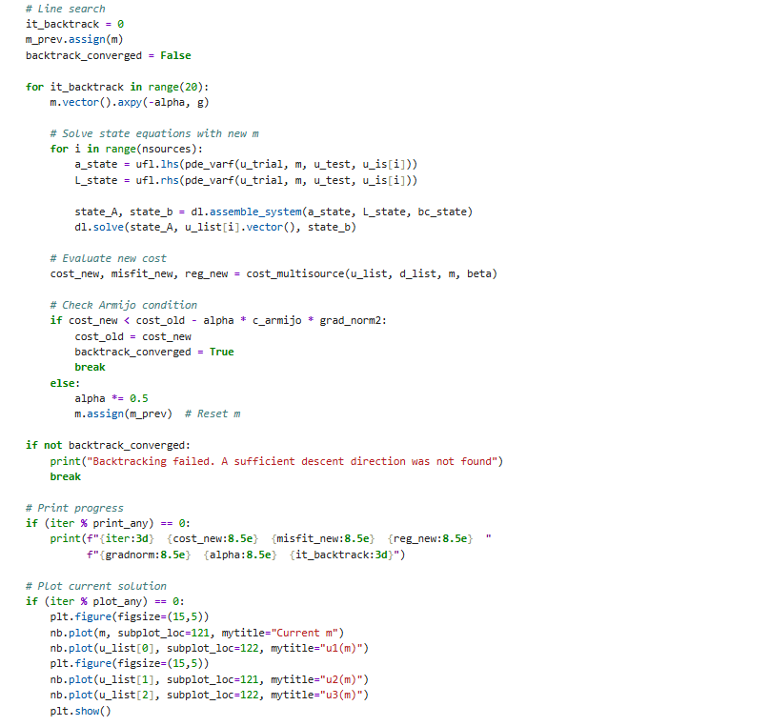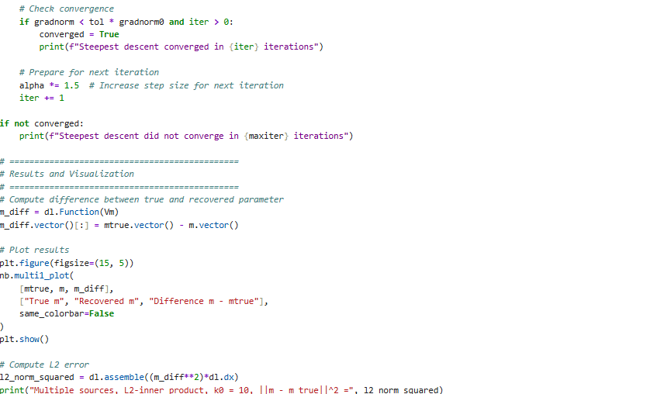
Repeated for k0 = 5.
III.1
Once optimal regularization has been identified:
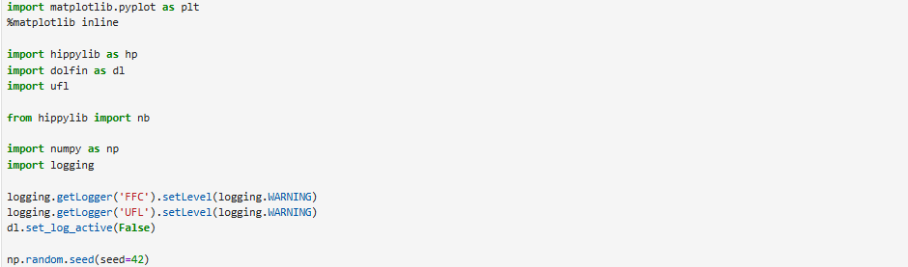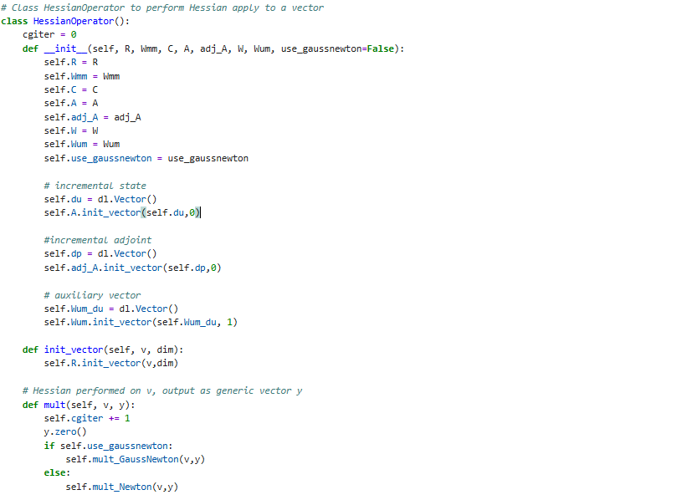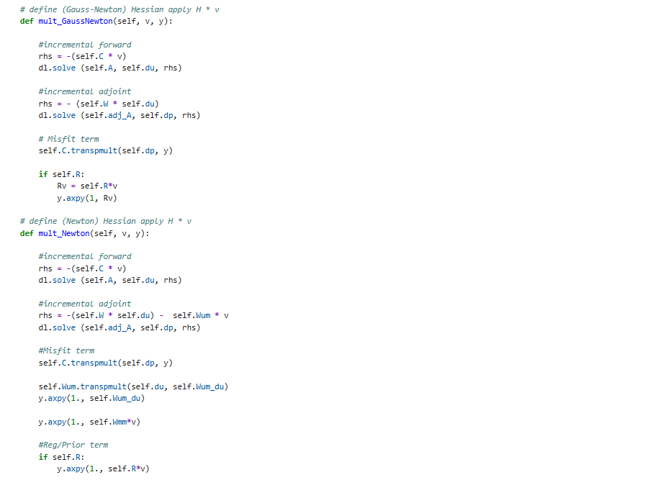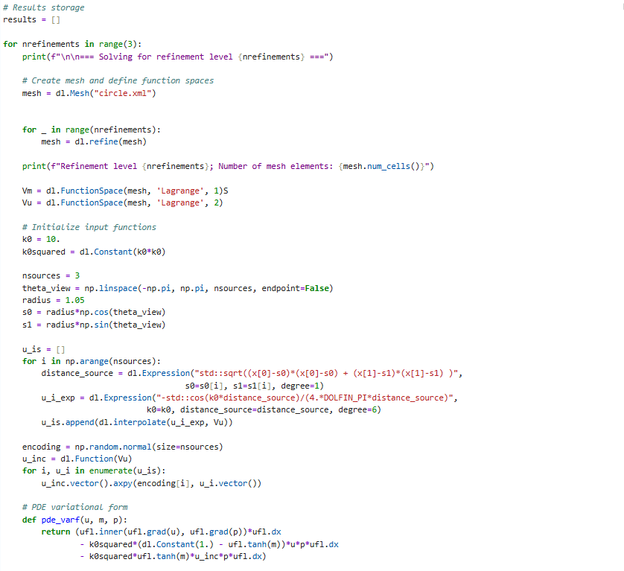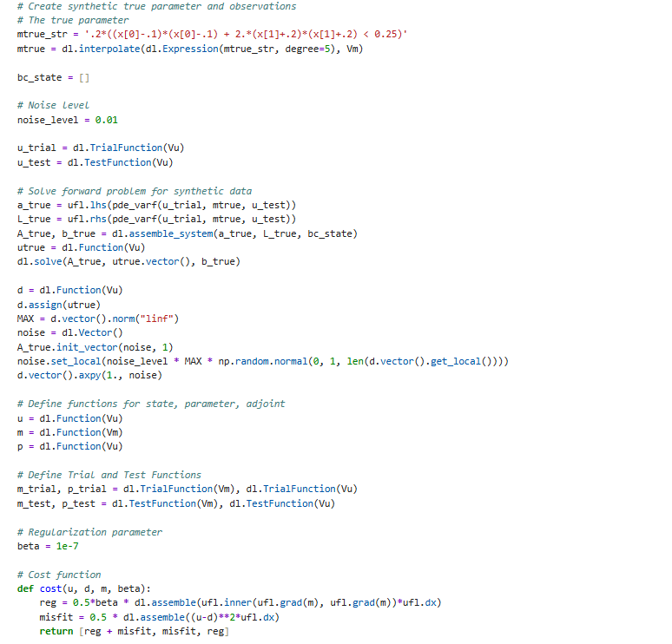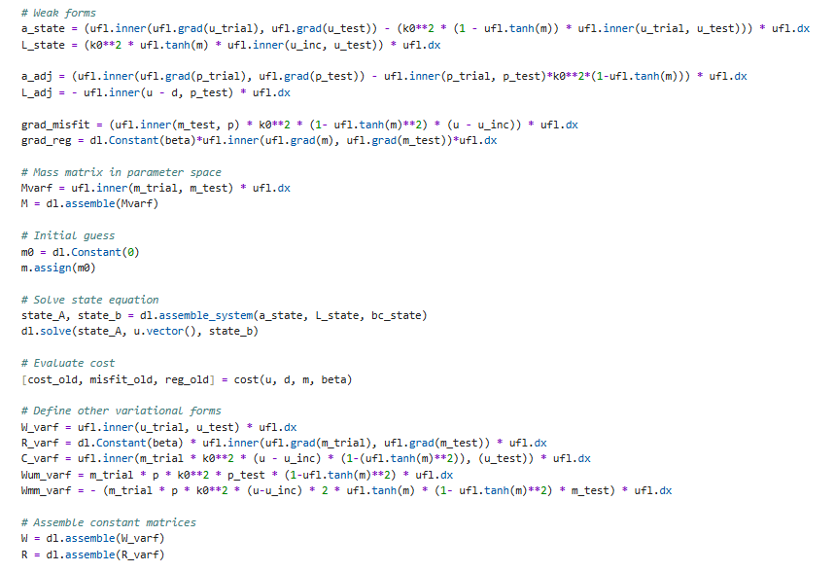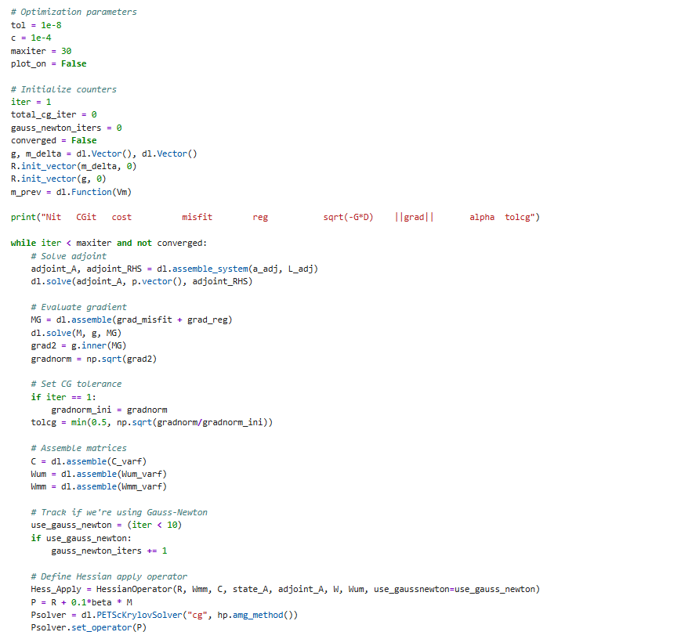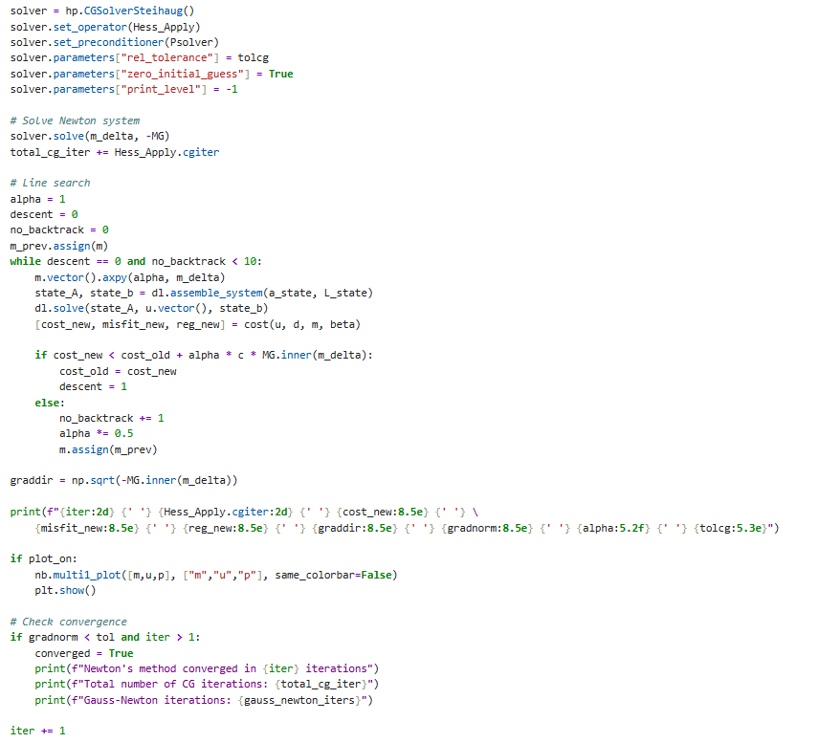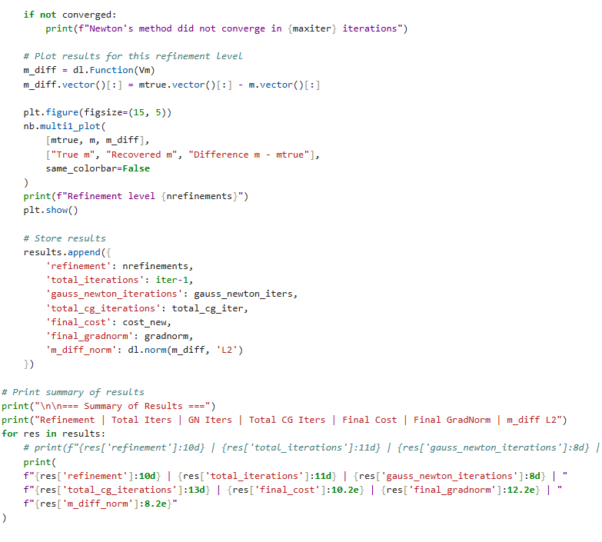
To identify the optimal regularization:
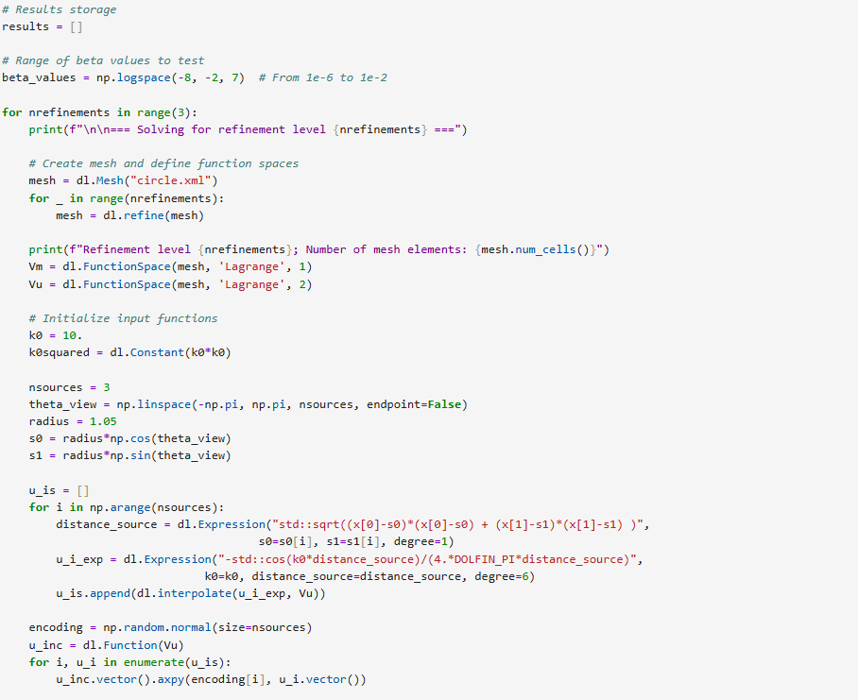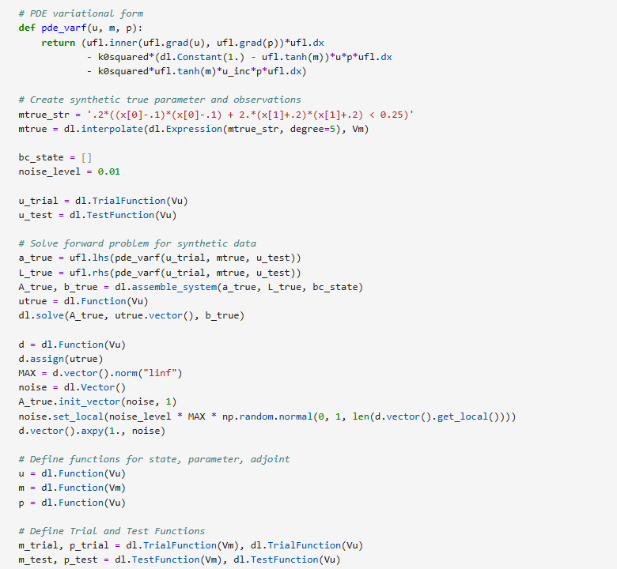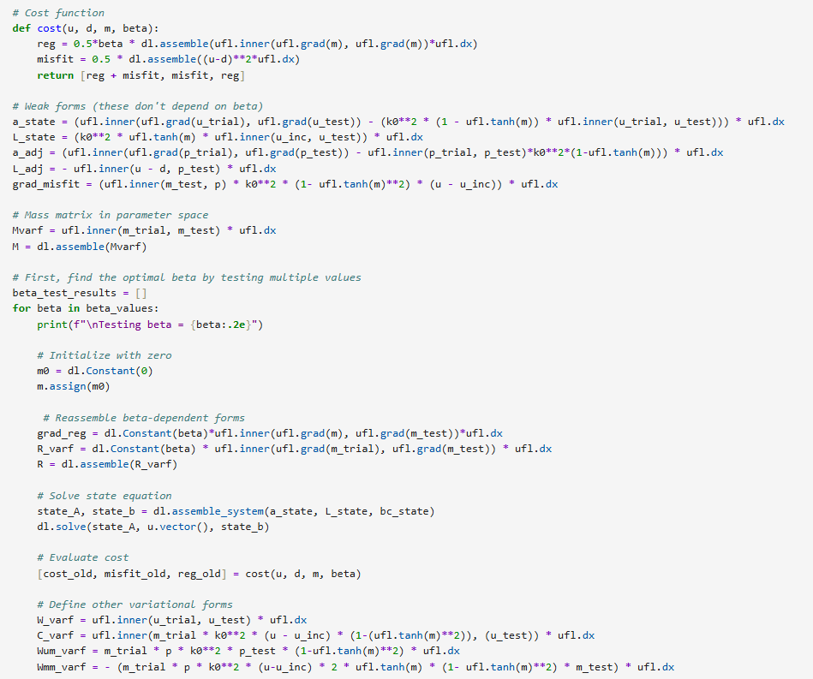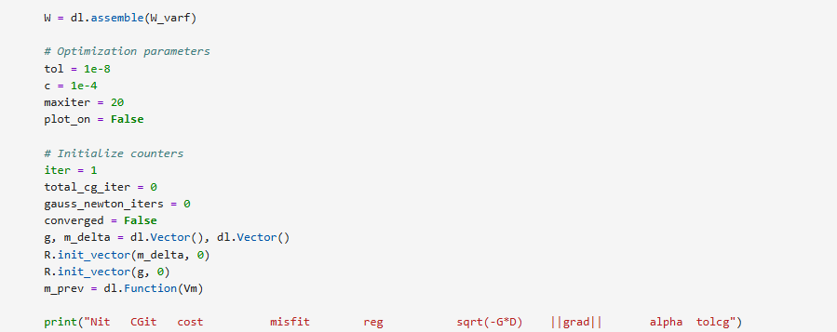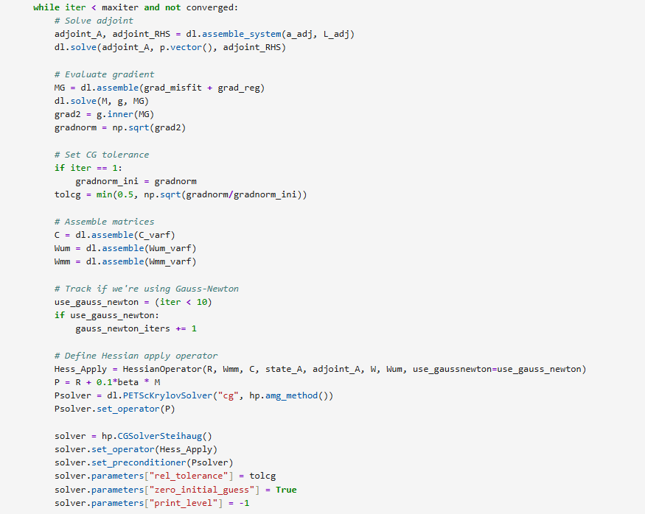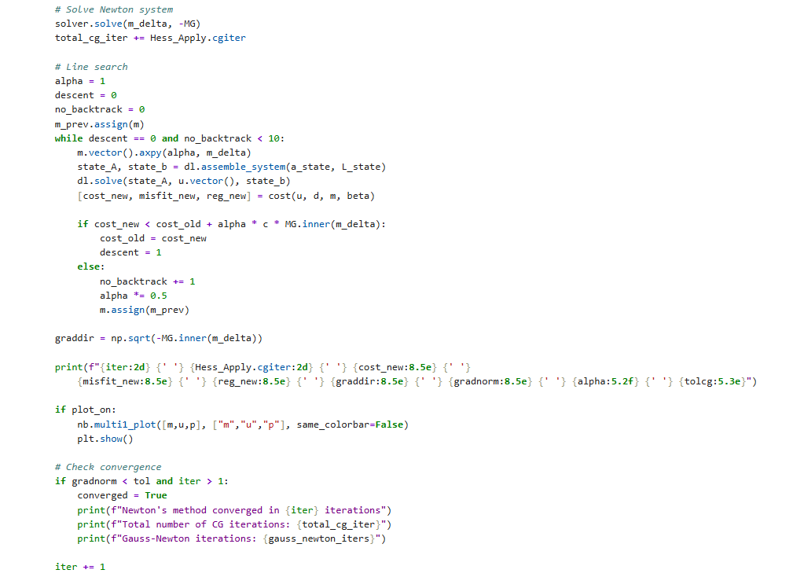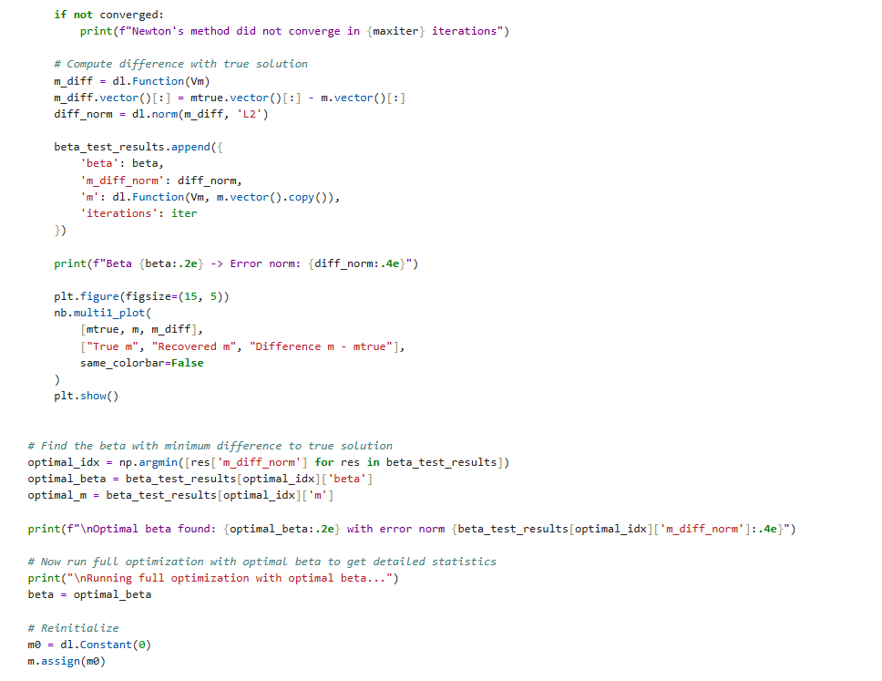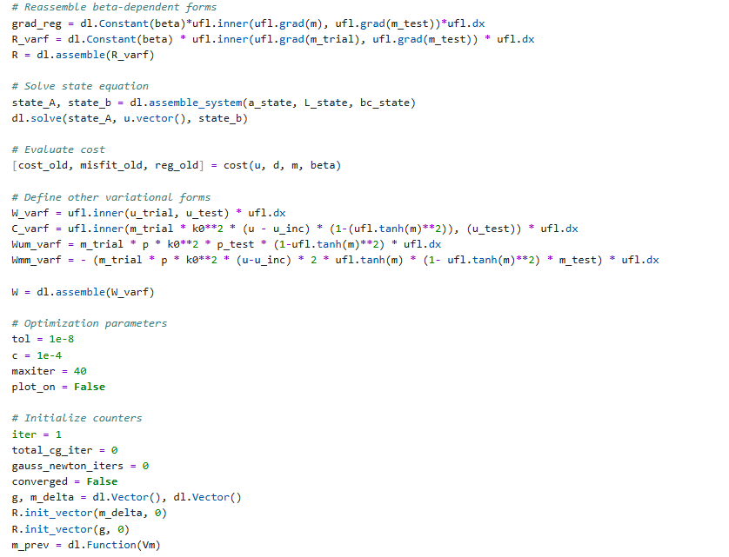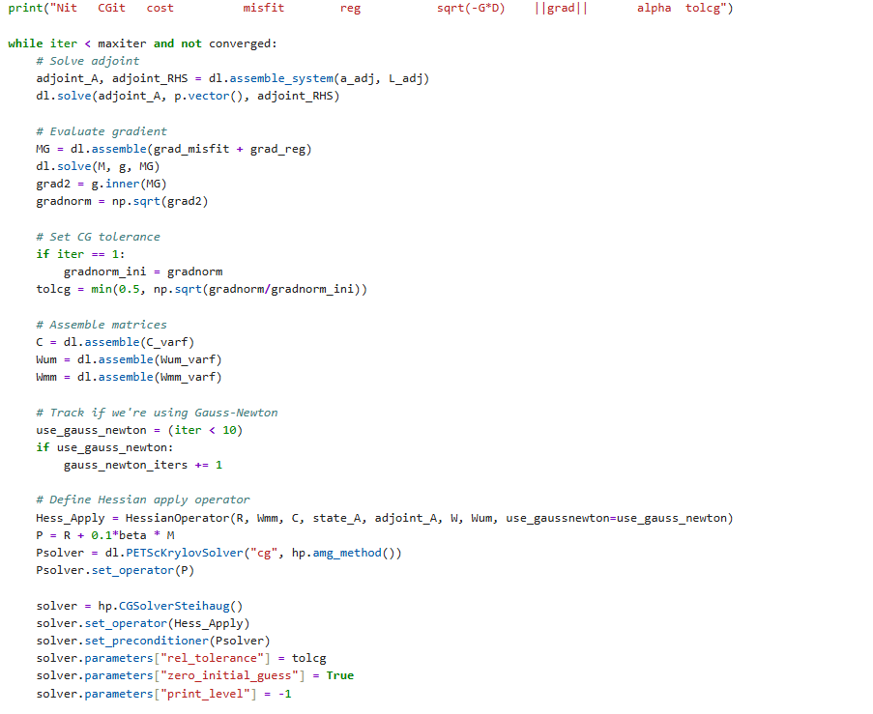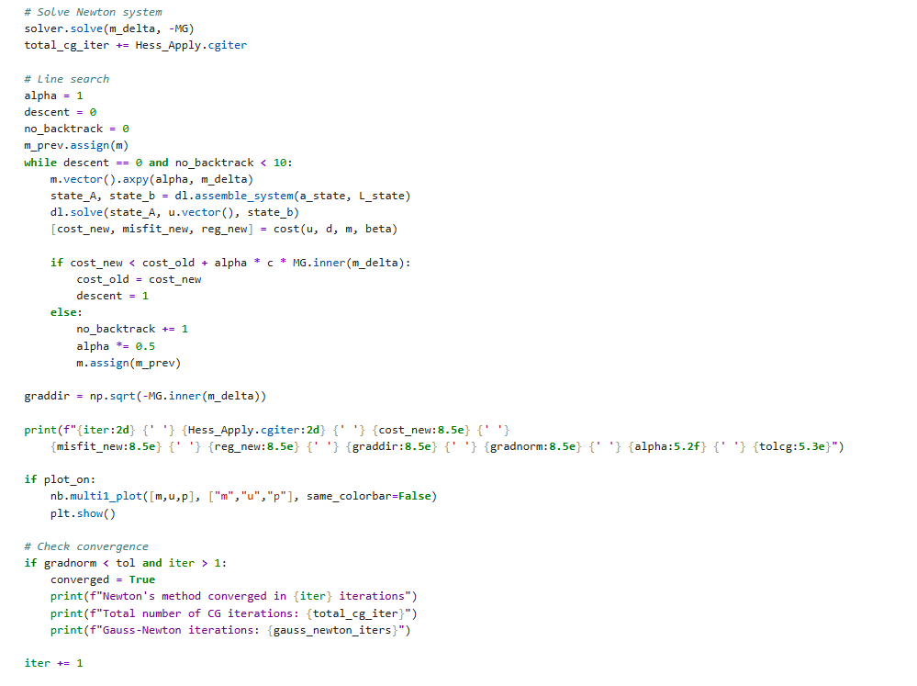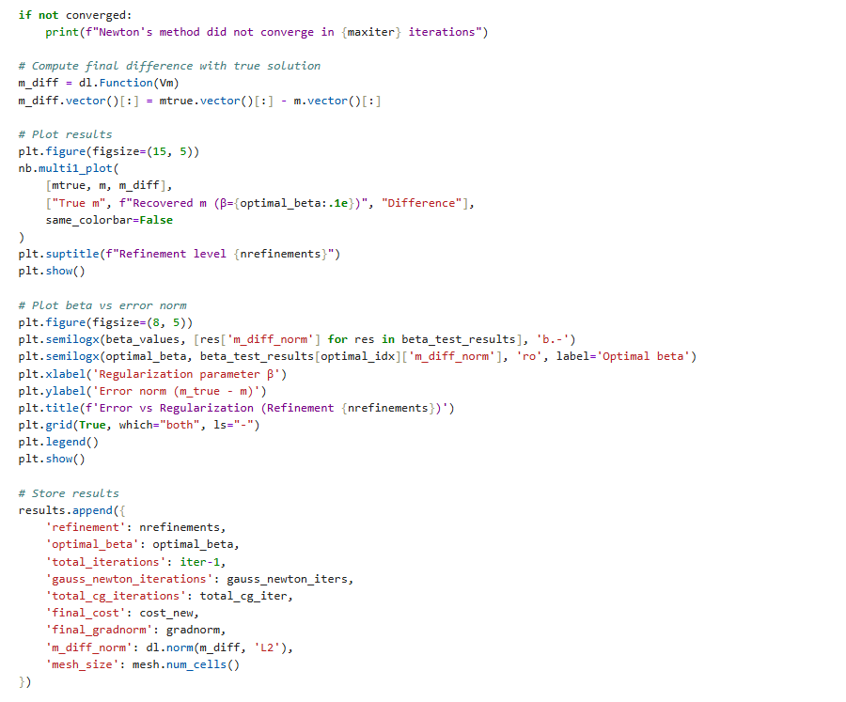
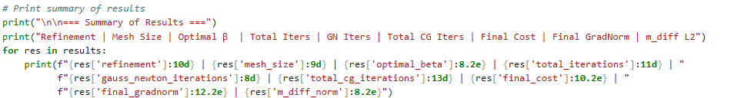
III.2.a
Same imports and class HessianOperator. 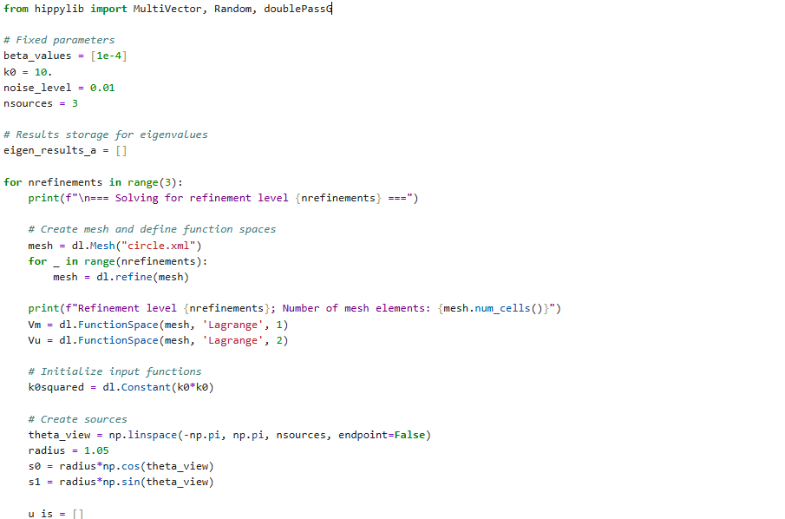 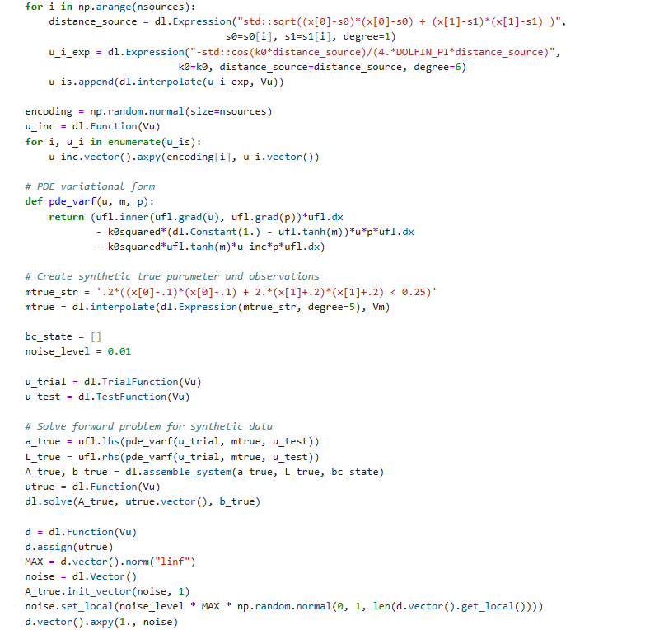
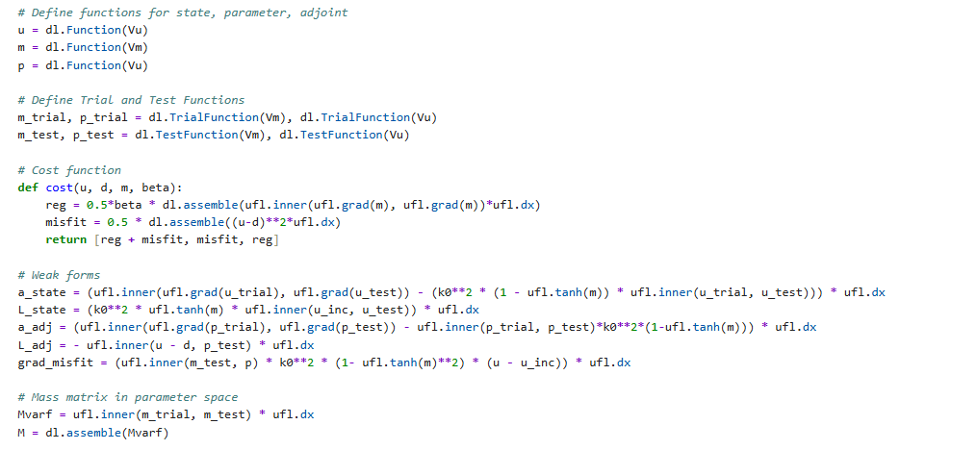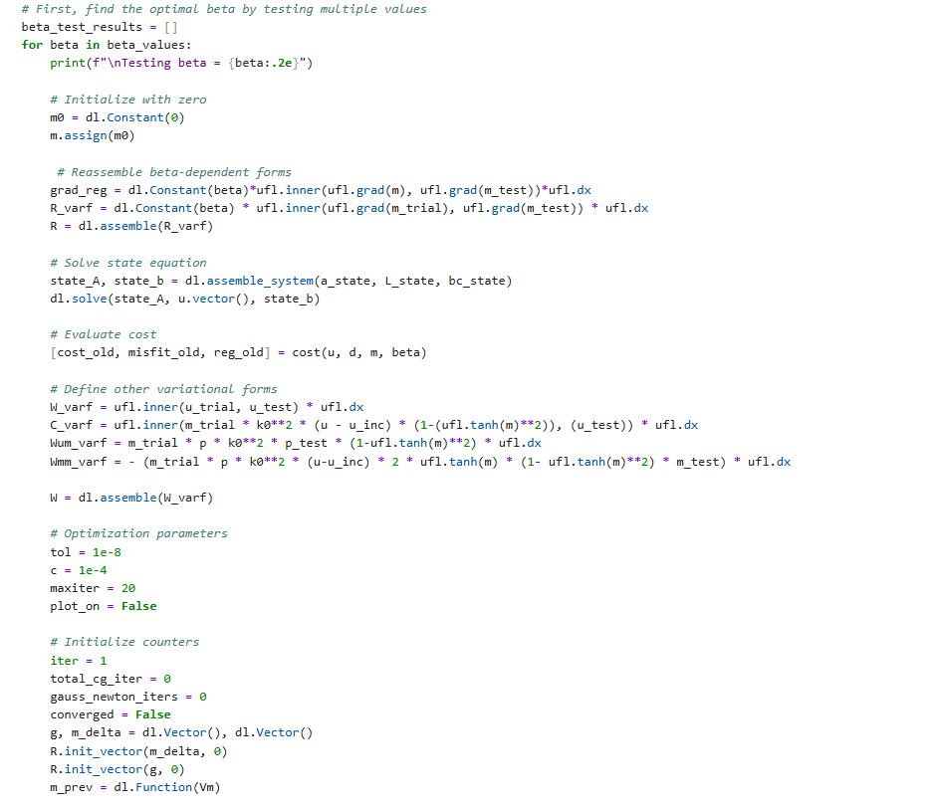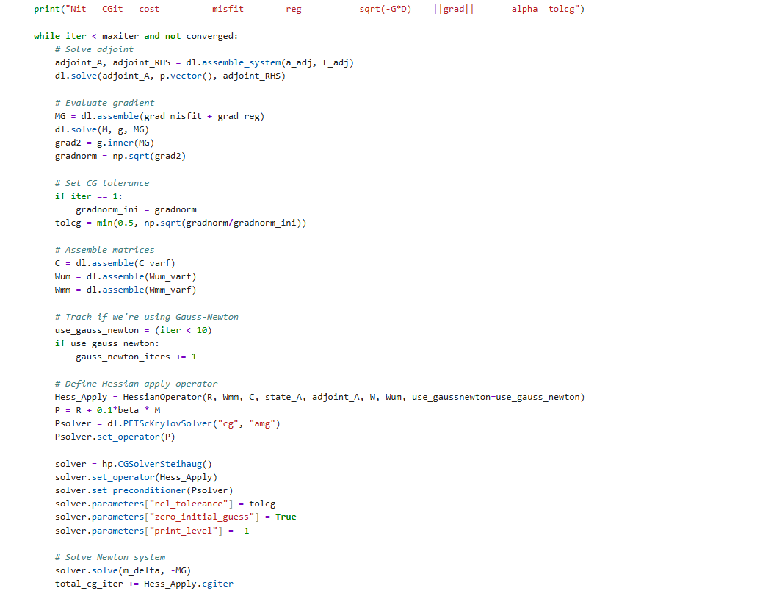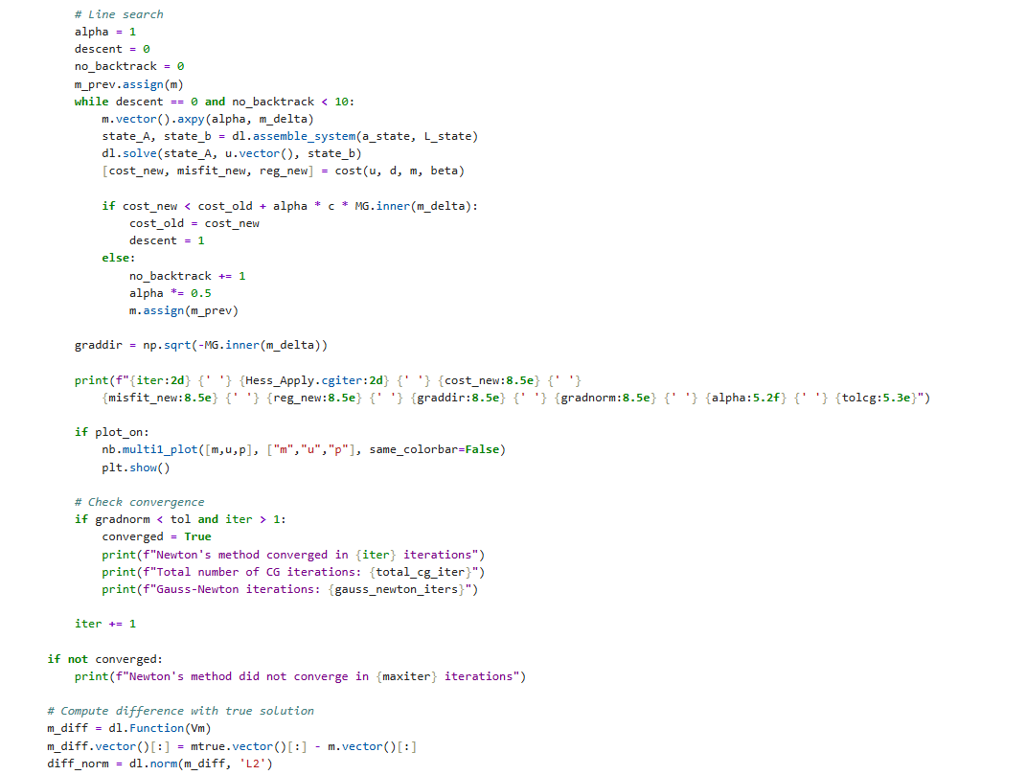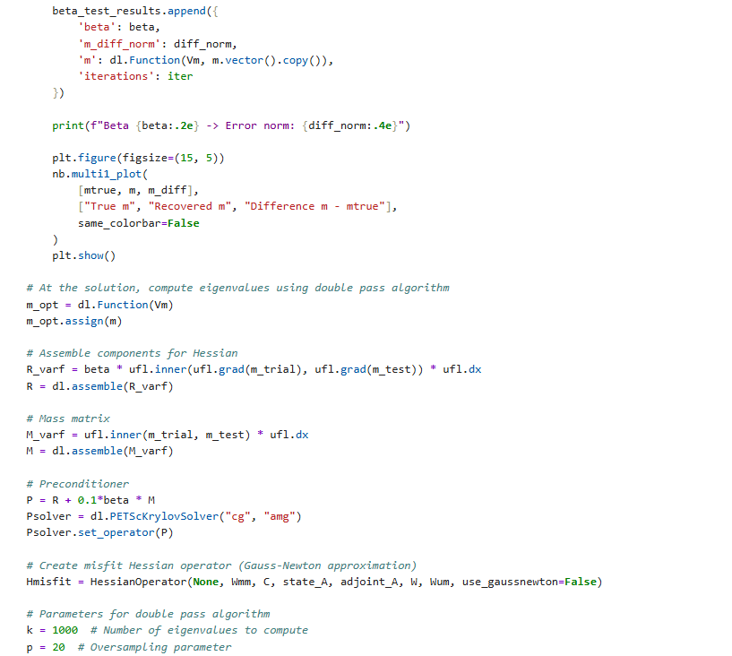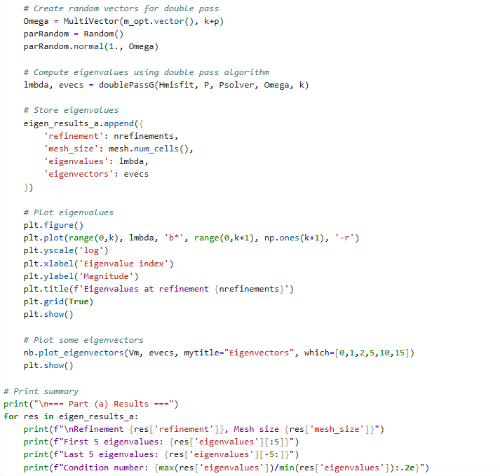
For regularized-preconditioned hessian eigenvalues:
Hmisfit = HessianOperator(R, Wmm, C, state_A, adjoint_A, W, Wum, use_gaussnewton=False)

III.2.b
For regularized-preconditioned hessian eigenvalues, use the below:
Hmisfit = HessianOperator(R, Wmm, C, state_A, adjoint_A, W, Wum, use_gaussnewton=False)

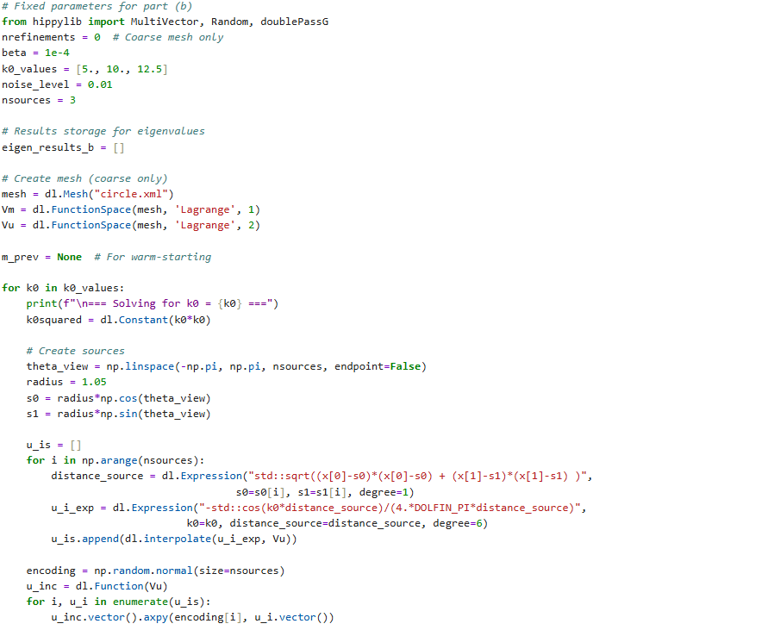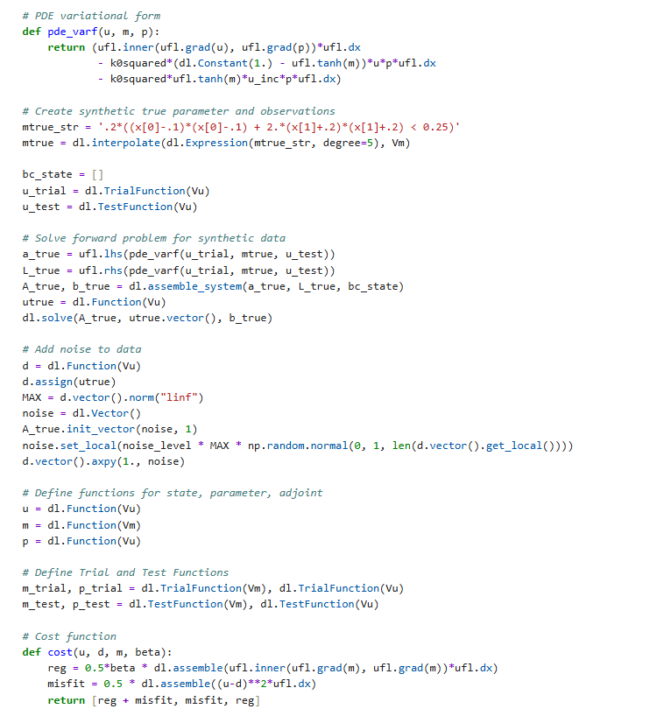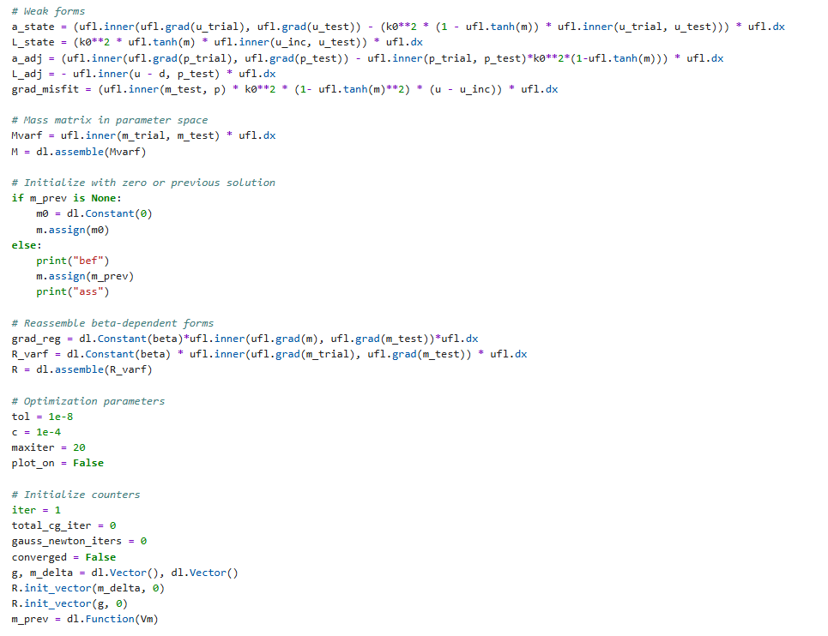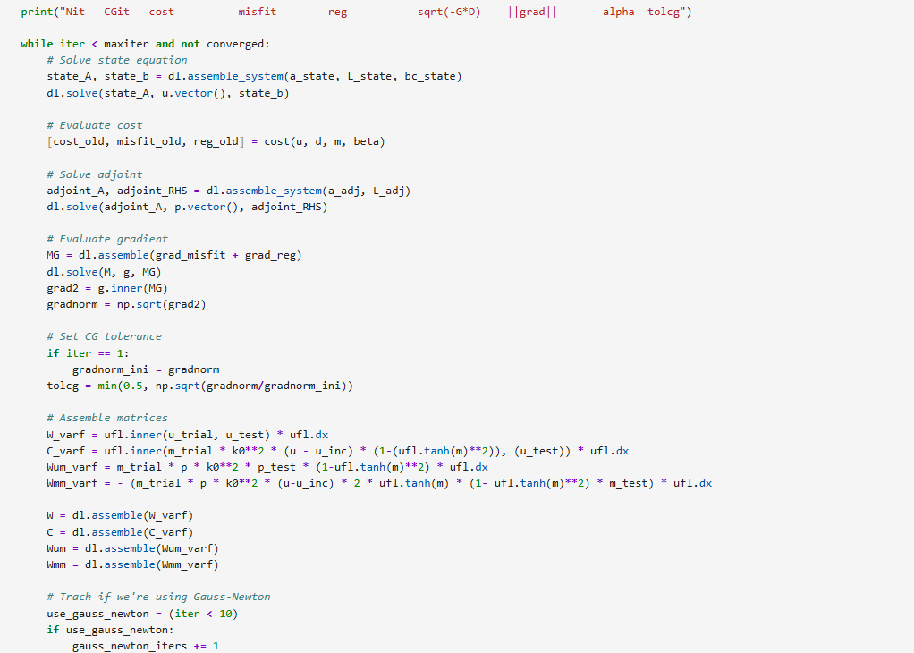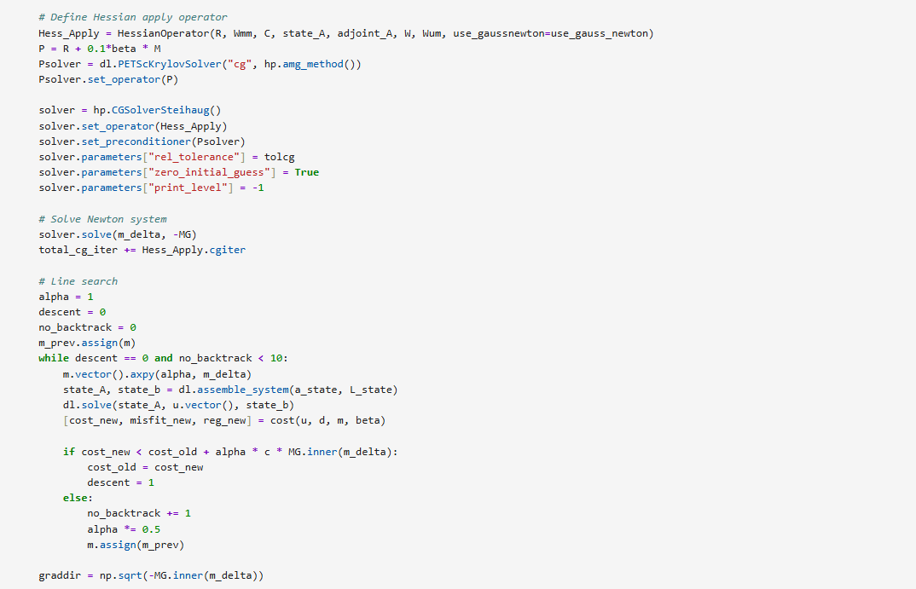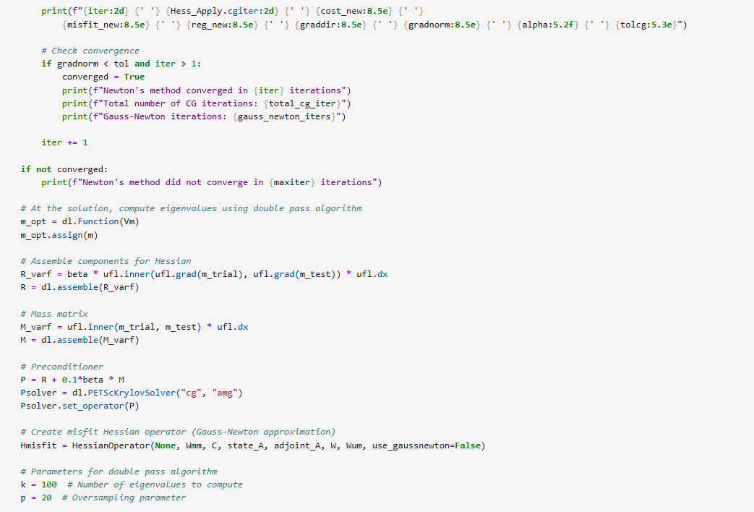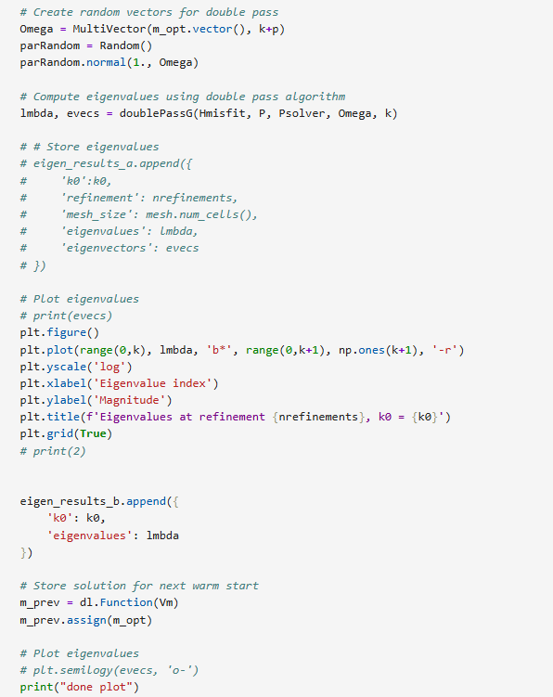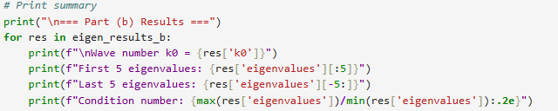
III.3
Same imports as above, along with the class HessianOperator.
